Note to Editor/Project Manager: this manuscript has been formatted to the size Dan gave me for a 7.5" x 9.25" book. Dan suggested a 6.5” x 7.5” printing area…………18,385 words

The Cemetery Book

A Visitor’s Practical Guide
by Joe Pegasus

For
Cathy, owner of my heart.

Poetry & artwork by Joe Pegasus
All drawings are found at www.mydrawingboard.com
Which is an archive of memorial designs
Unless otherwise noted,
Joe Pegasus created all featured drawings.
Every drawing employed in this book exists on
a permanently erected monument.

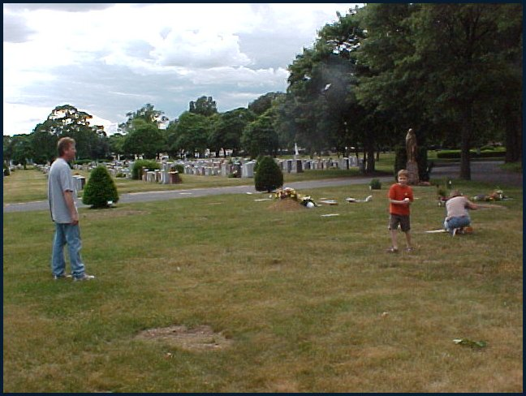
Playing Catch with Dad. While Mom decorates Grandma’s gravesite.

Who This Book Is For:

This may be your first visit to the gravesite of a loved one, and you need to learn how to go about it. You’re wise enough to know others might try to take advantage of you during your trip and that going anywhere for the very first time might hold an adventure you would rather side step. You may have visited a loved one’s resting place before, but it did not go as you expected. Sometimes, just a few words will help you along. You just need a quick and handy guide.
A cemetery is sacred ground. It is a park with gardens, lawns, inspiring architecture and monuments, as well as a refuge away from everyday life. It is a place of solitude where we, the living, park our beloved to stare down eternal time. We hope through our prayers that it is a launch pad into a higher form of everlasting life.
You're in a cemetery. You're standing before the gravesite of a loved one. You have no idea as to what to do. If you are a person of faith, you might say a prayer. If not, you may conjure up an old memory or two. Now what? Do not feel that you are in a friendly place?
Maybe atop the site sits a big rock with carved symbols on it, a gravestone. Maybe there’s a simple flat bronze marker. Or a military monolith. Does it carry any meaning to it besides a list of names and dates? What is that for? To hold your loved one down with?
Got some flowers you picked up from a local flower shop? Did you bring a vase to place them in; got water? And where exactly do you place them? How do you decorate a gravesite? Should you? Is anyone going to acknowledge your decorations? Anyone but you?
Another thing: where's the restroom? Is all this supposed to be so difficult?
I'm going to take you on a trip worthwhile. I'm taking you to a cemetery.
I have spent the last 44 years of my life studying people just like you. I am a memorial designer and builder. I am also a cemetery florist. But my number one job, my first love, has been to learn how to pay a visit, then help all the people visiting all those cemeteries everyday. It’s not a tough job, in fact it’s a highly rewarding one. Sometimes it can become emotional. That’s the territory and that’s why there are cemeteries in the first place. In this place we join together to overcome the finality of death and hold memories to ourselves, gather memories together and send memories to those yet unborn.
It is natural to be as close to the ones you love as is humanly possible. Unfortunately, right now, the closest you can get to this loved one is six feet or a slab of stone close. Say what you will about airy spirits winging their way above us in fluffy clouds, or sweet memories which fade or grow into gross exaggerations, yet the fact is she or he is right there in a cemetery. And, right now, so are you while wondering how to conduct yourself.
This book is a handbook, a reference, and a guide. I’m not taking you on a long-winded tour of the history of the cemetery. I’m not going to waste time with the superstitious aspect either. This is a practical guide for the practical person. And, let’s face it, you’re here unwillingly and saddened to be so. I understand. It’s my job to be your friend.

A Visit Is Not A Vigil



I am not alone when offering you a stern warning about over extending your visits to the grave of a loved one. Cemeteries are parks, and as such, should be appreciated and enjoyed. And used properly. It is not a place to hold vigil. The cemetery and the grave is a symbol of giving up the dead, returning back to nature that which She blessed us with and now takes back. Vigil is kept during the funeral rites. That was the time to grieve as well as to watch over and attend to the proper burial of the one you have lost. Both religious and secular ceremonies are formulated so that the care of the body is issued from your embrace over to the duties of the funeral director and onto the eternal care of the cemetarian. (Cemetarian or cemeterian is the person or office which administrates a cemetery. It is a legal word; witness Maryland General Assembly House Bill 1113. It is not yet in the Dictionary.)Your place from this time forward is that of a bereaved spouse, relative or friend. Do not apply the vigil beyond its scope or you risk your emotional and even mental stability.
Not to say what it will do to your social life.
Remember the old yawn: They have fences around the cemetery to keep people out. There’s a lot of truth in that statement. And a lot of sense. Cemeteries are highly regulated pieces of real estate. The organizations entrusted with their establishment and continuances are necessarily restrictive. The industry and art which goes into the creation and upkeep of a major cemetery is very serious business, not taken lightly by anyone. Besides the endless details and schedules demanded of a cemetarian, there are all kinds of forces to guard against. Such as the criminal who visits to steal, especially in cemeteries where bronze markers are employed. Bronze is easily melted down and sold. Visitors’ unlocked vehicles are targets for thieves as well are cemetery property and equipment. Solicitors can also be a nuisance. If anyone should approach you during your visit to sell you anything – flowers, a monument, refreshments – report them to the administration office or any cemetery worker. Such activity undermines management and places the sacredness of the park in jeopardy.
But there is one problem unsolvable by the cemetarian: the person who extends vigil. You might be approached by a concerned employee, chances are you will not be. Someone, like myself, after seeing you “hugging” a grave during my frequent trips into the cemetery in order to cut stone or deliver flowers, I might strike up a conversation just to evaluate your condition. To feel you out in order to suggest that life is “out there” not in here. But don’t expect that to happen either. One thing those of us in this endeavor learn early is to mind our own business unless asked to offer advice. However, if you’re handed a copy of this book from someone you’ve seen working around the area, re-read these two pages again – for your own good.
The extended vigil is dangerous because it slowly consumes you. The normal term of bereavement waxes and wanes from 18 months to two years. You will schedule visits after church, on weekends, with family. There will be spontaneous visits. Do not expect to have memories fade or drop away during this time frame, they will not. Expect to get emotional, especially during visits. Don’t be embarrassed or hurt yourself holding back. Everyone you will meet during this time – the funeral director, the monument builder, the cemetery personal and the florists – expect you to be upset. And you’ll find, whereas the others present their services with the utmost care and formality, the florists will handle you differently. We are your attendants during the bereavement process. You ‘think’ we’re just selling you a pretty bunch of flowers, meanwhile we are watching you, always trying to move you along and out of the bereavement phase. You may think: but doesn’t that reduce your sales and clientele? No, the clientele is endless and what it achieves is two fold; we helped create a happy and friendly customer and we enforce the sacredness of the process. By the end of the process visits are rare, restricted to holidays and sometimes only virtual (Internet) visits. You have left no one behind by evolving like this. You have simply returned fully to the world of the living where you belong.
But those who hold vigil are beyond our reach. They seldom, if ever, purchase gifts to bring to the grave. They have this sad tunnel vision which takes them from home to the grave and back home again. They often remain in their car, parked so as to see the gravesite. It is made worse, horrible in fact, when the infliction claims more than one person. Such as a couple who have lost a child and can’t manage the pain. I personally knew of a couple who lost their 8 year old daughter and they both fell down because of it. They parked at section 18, range J in St. Charles Cemetery everyday – rain or shine, snow or storm – for 14 years. They kept to themselves and although everyone in my world knew of them, no one (that I know of) ever knew who they were. They are persons in trouble, unseen and helpless.
The friends we need to worry after are those who cannot afford professional help. The world is a community and we all need to hold vigil over each other, not the dead. If you recognize such behavior in friends or relatives, speak openly to them about it. They know they’re stuck in their grief. Bring it to their attention that you know it also and it also affects you and is dangerous for them. If you, yourself are suffering because you just can’t let go, talk to others about it. A confessor, Rabbi, friend, relative, me. Don’t discount or predict what the cemetery worker or the florist girl can offer you. We’re not in the business of mental health, however, it is certainly part of our business.
This book can be helpful in as much as it offers you everything there is to know about visiting the grave of a loved one. Notice it’s not a very thick book. There isn’t much to this. There need not be and there should not be.

Part I Making the Visit.

Before Leaving Home
Never make the first visit alone. Even if you are emotionally set about making it through your first time, bring a friend or relative with you. The extra pair of eyes and ears can be handy during a trip to an unfamiliar setting.
Bring this book. Part III was specifically written to be read at the site.
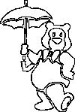 | Flats - do not wear high heels even if visiting a mausoleum.  Umbrella - expect any weather situation. Dress so you add or subtract clothing easily. In southern cemeteries expect tree moss and their insects.  Purse – Not all cemeteries have security. You will not get mugged, but if your car is parked out of sight hide valuables and lock the doors. Take the keys. Wear your purse attached to your person.
Umbrella by permission from Derick Earp
 | Map to Grave - unless you absolutely know where it is. If this is your first time after the burial, do NOT trust your memory. If it has been more than 2 years, expect changes in landscape and more headstones to wander through.  Cone vase - the extra one you had and put in the trunk. Didn’t you?  Grave Decorations - if not stopping at a flower shop. Some cemeteries and many public mausoleums will either not permit decorations (gifts) or supply them already. Know your choices.  Container of Water - should always have in car anyway.  Cell Phone – or alert someone as to where you are. Breaking down in a cemetery, especially a rural one, can ruin your day.
Homemade gifts are often sweeter than store bought presents.
 | Tools - especially if you will be planting.  Chair - it’s also a park and you might want to sit awhile.  Tissues – It is remarkable how many folks do not remember tissues.  Camera – does a shut-in relative need a picture of the site or the gifts you bring? Do you need an image for legal or personal reasons?  Memories - You may not be in mourning, still, now is the time to Remember as well as to flush out sorrow.

Pit Stops

Smaller cemeteries will not accommodate us with restrooms. Some flower shops might, most will not. All monument retailers will, but may insist that you be a customer. Funeral parlors can be found near rural cemeteries, not near grounds in major city areas.
Especially during your first visit look for:

Gas up - you not only have to drive to the cemetery but through it. Consider you may also need to stop or make a side trip along the way. Keep an eye out for service stations.

Snack - If you do not bring a snack to consume at the cemetery, then spot all the nearby eateries while in the area. Families who “meet” at the grave often lunch together afterwards. Know where to go.

Accommodations - If the cemetery has an office onsite, check with it concerning a restroom and other accommodations such as maps and escorts to the gravesite. If you or someone with you is handicapped, do not expect easy access to gravesites; most are in park settings with no predefined walks. Review the cemetery’s accommodations, rules and regulations. Each cemetery has its own planting season and types of grave decorations permitted. I will assume there is already a stone or marker on the grave, and will review these later for you. Most cemeteries, even an old one, now have a website. Check that resource for detailed information and for grave location.

Flower Shops - You will eventually settle with one to your liking, yet visit them all. Most cemeteries have several flower shops around with stiff competition among them. Therefore each shop will target a specific customer. Find the niche that suits you best. Do not purchase from super markets or roadside stands. You can get deals from such, however, they are not in the business to support your visit to a cemetery. They don’t even know if the flowers they sell you are permitted. The quality of the flowers is pitiful. They also will not stock items exclusive to grave decoration. And, for the most part, these folks are visitors to gravesites like you; they don’t “walk the walk and talk the talk.”

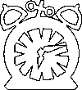 | NEVER BE PROMPT …. When visiting major cemeteries on holidays it is best to visit early and late. Unless you want your memories and mood destroyed by bumper-to-bumper traffic and road-rage. For example, for Father’s Day visit during the week before or after the holiday.  Drawing by permission of Derick Earp

The Tree By Every Grave

Almost every person who stops me during my frequent trips to a memorial garden, is wanting for directions. Some inquire about water taps, some about services they missed on their way into the cemetery. But, for the most part, it’s people who thought they recalled where the site was, near a tree or a road or another landmark which disappointed them this time around.
Things do move around in your garden at home, they do so here also. A tree may not move, but eventually will be cut down as it ages or becomes unsightly. Water sources and buildings, fountains and roadways usually remain in place, though one never can be certain. The only items in this garden which remain exactly where they began are the grave markers. But, if markers have been added since your last visit, then compound that with changes in the scenery and you’re lost.
Like a well planned city, a cemetery is designed to be a grid. Your right of burial certificate (commonly called a deed) reads just like a plot plan found in any architect’s inventory. Sections, blocks, plots, ranges, rows and the site itself guides you to it. Know your “Section Numbers.” Either memorize these numbers or carry them with you when visiting. For two reasons specifically: 1) To locate the site, 2) To identify it to a cemetery employee if you need to do so. Too often I have stood completely puzzled when trying to help someone either lost or reporting a situation at the site. Telling a cemetery worker that “yer know, it’s by that maple tree that’s near the bunch of pine trees close to the fence near that back road.”

What No Vase?!?!?! …. Within cemeteries that supply vases to grave markers it is not uncommon to find your flower vase missing. Report the missing vase to the administration office. Meanwhile, it is not improper to borrow a vase from another marker to use in the missing ones place. Most vases are interchangeable. Also make mention to the office that you made the switch so they can replace it.  Drawing by permission from Art Stone Memorials | 

The Gifts You Bring

Under almost all circumstances only two people will ever handle or see what you bring to a beloved once it is placed; you and a cemetery maintenance worker. Only one of the two will appreciate the gift. Due to this fact, a gift placed on a grave is the expression of extreme personal affection and an act of true love, friendship and/or honor. You do yourself great spiritual building whenever you visit a grave. You perform a feat of deep emotional maturity when you give a gift to the dead.

Even though no one is there to accept your present, or thank you for it; even though most gifts are costly, fully 98% of all cemetery visitors bring gifts to a gravesite.
Often we all hear discouraging words concerning visits. “The dead are not there.” “I’d rather think of him as he was in life.” Well, let’s be real about this: they are there, indisputable. And, would you bother with any thoughts except good ones, ever?
Do not spend foolishly on decorations. All the decorations in the world will not bring anyone back.
The best gift is the gift you made by yourself. Keep an eye open when at craft stores and local flower shops for clever items to build your own decorations with.
No decoration will remain at a gravesite. If a busy cemetery did not remove decorations on a rotating schedule, within a month the grounds would become unsightly and perhaps dangerous to be on.
Do not leave anything of great value as it can be stolen or borrowed.
Consider a florist for its function as a grave keeper when you are too far away. Most shops will mail photos of their deliveries and work. Some maintain websites so you can perform virtual visits.
Endearment Tags (also called Beloved Tags) are paper strips or ribbon with personalized sayings written or printed on them. Seek a shop which will custom print tags and custom build floral arrangements as well. Seldom will a shop charge for custom tags. It’s the difference between a ribbon which states: ‘Beloved Friend,’ and ‘My John.’ Or, ‘In Loving Memory’ and ‘Johnny, You’re always in my heart. Love, Jane.’
Pics are colorful plastic signs atop long picks which are placed among the flowers of a bouquet or attached to artificial pieces.
Artificial Flowers are always your best choice. They stand up to all environments and most cemeteries will not disturb them until they become unsightly – which is a long time. The meaning of an artificial rose is exactly the same as a fresh one. A rose is a rose is a rose.

Pre-arranged Grave Decorations

From the Director/Cemetery
Throughout America, notably in the South and alongside pre-twenty first century churches, cemeteries are under the care of a funeral director. The director wears several hats. The undertaker, the cemetarian, the ground keeper, the monument builder and setter, and the florist. Usually these cemeteries are under five acres and all departments lie within the office of the director. Where a church graveyard is concerned, the pastor may and may not share in the duties. To make this arduous career as simple as possible, the director will design the cemetery so as to accept only flush (flat) bronze markers. This form of monument allows for lawn mowers to drive over the graves unlike with upright monoliths which require careful navigation. It also affords no hiding place for animals or human trouble makers. But its best advantage is that the director can contract with the family for decorations. At the time of the purchase of the site choices such as from one year to five to an on-going basis can be offered. Often such accommodations are far more economical than if you were to attend to the decorations yourself. The director will place artificial flowers (especially in the South) in the vase attached to each marker and change them when they become unsightly. A good artificial bouquet can last upwards of 4 months in the North and 2 in the South and West.
This does not restrict you from fulfilling the need to pay your respect with your own gift. Room both in the vase and around the marker is almost always reserved for your personal decoration.

Pre-arranged Grave Decorations

From the Flower Shop
Not all flower shops will make deliveries to cemeteries. And I include shops alongside major cemeteries themselves. Although those who will not are happy to recommend sources that will. A cemetery florist, unlike a residential/main-street shop, holds a captured audience and often must turn away a percentage of business to remain at a desired level of customer satisfaction. Because deliveries require man-power and often a considerable amount of time, a fair percentage of shops will either sub-contract the work or deny it.
Most shops will accept deliveries in all forms. Many, such as my own, will maintain the site upon delivery, send along a photo, post the image online for virtual visits, and supply order forms per holiday, per request and per year. The benefit of having a shop behind you is that custom arrangements are more the rule than the exception. And a shop will always place the gifts with the expectation that you or another may visit and add items besides these.

 | But I’m Jewish, I Bring No Flowers!  If you are visiting a friend or relative’s grave whose site is in an ethnic cemetery and you are not familiar with the traditions of the culture it is forgiving of you not to bring anything for the first visit. In fact it is traditional in most cultures, including our own, not to do so. That is why your very first visit to a gravesite, the flowers are brought by the funeral director only. You come empty handed until after rites are performed. Then, in most cases, the director will hand out single roses or carnations for you to present directly upon the coffin or outer box.  Hebrews carry a different tradition also. Their vigils are short. They adorn each grave as uniquely as is possible and, though they stack bury like most others (pile one on top of the other. More on that later.) they will place a stone marker for each individual, whereas, others simply add names to existing markers. Traditionally, visitors will not bring gifts. Instead a visitor will look around the site for a natural rock and place it atop the headstone of the person visited. This is to recall the days when shallow graves needed constant care to fend off animals. Then visitors repaired, adjusted and added to the cairn. Some sects will bring pebbles from off cemetery grounds. Usually in a small bag and place the bag atop the stone or at the head of the grave.  No one is going to chew your head off if you bring flowers to any site in any cemetery. If you feel empty handed, bring a single rose even to a Jewish friend. However, keep in mind that if a cemetery for traditional or merely policy reasons restricts gifts, they probably do not have a regular clean-up schedule or crew. That single rose will wilt and become unsightly. Always attempt to know the rules. As you’re a visitor, you are also a guest. Don’t be an unwelcome one.

KNOW YOUR FLOWERS

Why do you find different flowers at cemetery florists than at residential shops? Because flowers, besides being utterly beautiful, also communicate.
Here’s what they are and what they mean:
CARNATIONS  Usually called CARNS | The hardiest of fresh cut flowers and tolerate all weather conditions.
PINK CARNS | Remembered always.
BLUE CARNS | (Dyed) Flowers for a male.
RED CARNS | I miss you.
PURPLE CARNS | Sorry, I can only visit once in awhile.
PEPPERMINT CARNS | Wish you were here.
WHITE CARNS | Sweet, lovely, innocence, purity.
Although a flower’s color states a message, an abundance of cardinal colors refers to gender. Red and Blue for men. Pink and White for females. Yellows for friends. Purples for relatives.
Chrysanthemums - usually called MUMS | MUMS are employed as filler or specific design flowers.
PINK MUMS | (usually dyed) for a female.
SPIDERED MUMS | I’ve come to spend my time with you.
PURPLE MUMS | I miss you so much it hurts.
WHITE MUMS | I accept the loss. This is real and true.
YELLOW MUMS | Beloved friend.
DAFFODIL | Unrequited love. You're the only one.
DAISY | Loyalty.
LEATHER LEAF – you call it FERN | I bring you magic.
GLADIOLI | Accept my visit.
SUN FLOWER | Power, you were my king.
STATIS | I remember our love.
BABY BREATH | Your memory is renewed.

KNOW YOUR FLOWERS

LILLIES | Speak in absolutes.
WHITE LILY | Virginity, Purity, Majesty
YELLOW LILY | Not of this world.
ORANGE LILY | Proud of you.
CALLA LILY | I recall your beauty
LILY OF THE VALLEY | You made my life complete.
Potted Lily of Valley | Hope you have happiness.
Potted LILY | You are a saint.
Buying for a shop is art. Most, if not all, cemetery florists buy top of the line flowers with closed buds because the florist has control of the bloom and because hardiness is the key to customer satisfaction. These flowers must endure weather and open environments.
ROSES | Speak to and from the heart.
In a cemetery flower shop the variety of the rose is not as important as the color and size. A red Madam Delbar rose means the same as a Red Fancy rose, however, because the Madam is larger, it means what it says only more so. Size determines intensity.
RED ROSE | Mourning.
YELLOW ROSE | You were not my love, but my friend.
PINK ROSE | Perfect Happiness
WHITE ROSE | Innocence -specifically in death.
LAVENDER ROSE | I'll remember always.
STAR FIRE ROSE | Unity
PEACH ROSE | I’m here to heal myself.
Flowers carved in stone or cast in bronze carry a significantly different message. Bringing a gift to the grave is an act of love, respect and honor. A monument is a permanent message and should be designed so the memory of the deceased is revitalized each time the monument is viewed. We’ll speak more on that shortly.

In everyday gift-giving, flowers take on a different meaning. I have listed these in Appendix A. Sometimes you want to bring flowers from home or a residential shop when you visit for reasons other than memorialization. Such as when you have a personal event happen and feel a need to share it with that loved one - ‘Hey, Dad, I got a raise today!’

The Basics about Flowers
Because your funeral director and your monument builder usually focus on their particular tasks, it falls to the florist and the cemetery office to explain proper decorating procedures.
Be sure to have water on hand. In the North many shops will supply free water along with the flowers they sell. Because cold climate cemeteries will not supply water from November through April. Look for signs at the administration office or ask what their water schedule is. Eyeball water taps in the section where you are visiting. Have a backup in the trunk.

Expect to handle some trash. Taking flowers from the shop without a wrap is asking for permanent green stains on your clothing. Discard wrappers properly. Which means A) Remove paper when you leave. B) Fold or crumble the wrap and place alongside grave for the maintenance crew. C) Locate trash bins.
DO NOT place wrapper in the vase. Paper will form bacteria, which will kill the flowers.

Know the rules and regulations. Some cemeteries allow only fresh cut flowers, some allow them seasonally. Do not ignore these rules. They exist to safeguard you and cemetery workers - stepping on a metal florist pick is cause to visit a hospital. Illegally placed flowers will be discarded earlier than you would like. Cemeteries that employ flat markers - bronze or granite - usually pride themselves for their garden look. They will restrict decorations to one floral bouquet and very often offer you a permanent vase placed according to their design at the site.
Cemeteries with headstones will accommodate areas in front and on the sides of the site for placement of decorations. The common rule is 18 inches forward of the stone and half the distance between your loved one’s stone and its neighbor. The 18 inches can be squared or half circle. Do not clutter; flowers need to breathe. And unsightliness is asking for a quick removal of all decorations. I’ll present you with decorating ideas later on.

Artificial Flowers are always your best choice. They stand up to all environments and most cemeteries will not disturb them until they become unsightly – which is a long time. The meaning of an artificial rose is exactly the same as a fresh one. A rose is a rose is a rose.

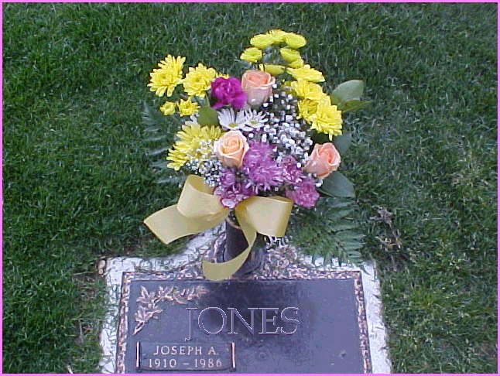
Cemeteries that employ flat markers will restrict decorations to one floral
bouquet and offer you a permanent vase.

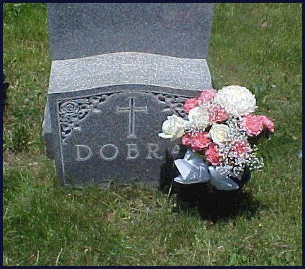
It is best to place a bouquet to the right or left of center so as not to hide names.
Placing flowers up against a granite stone will not stain the granite or damage the flowers.

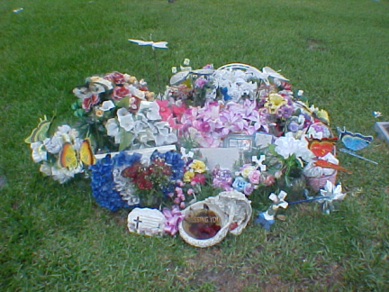
What not to do. Especially with children, some times too many visitors bring too many gifts. If in this situation, leave the fresh flowers and store the artificial until your next visit.

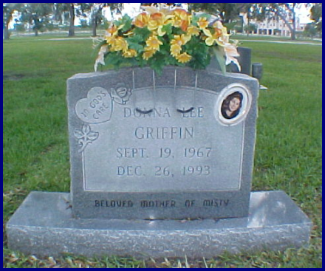
Saddles are common in most rural cemeteries, but you’ll also find them in major cemeteries as well. They sit atop stone monuments. They are made of durable material and can last for years.

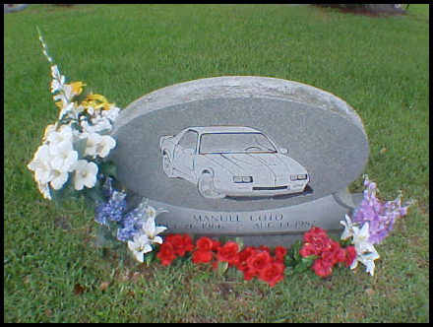
Clever decorating around a cleverly designed memorial.

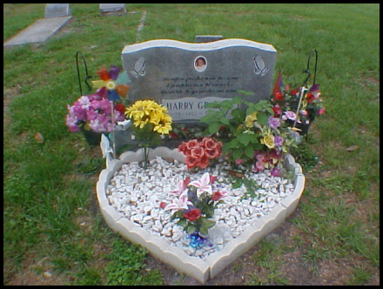
Larger cemeteries will not permit you to plant or decorate so far from the front
of the stone. Tractors and human traffic prohibit a liberal use of ground space.

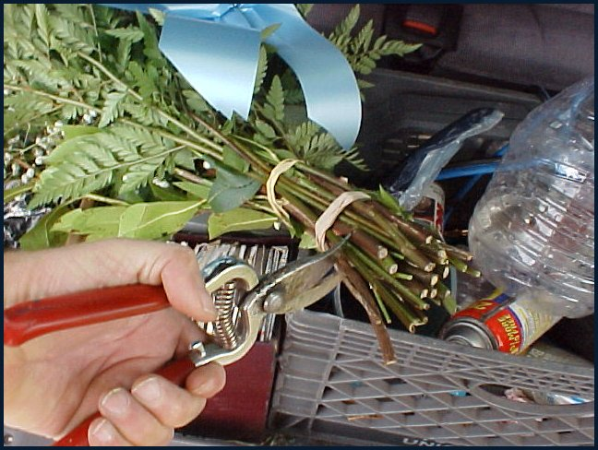

Carry clippers. Doing so is just good advice. You never know when you need them. If you want a clipping from a plant that surprises your path, wiggling off battery terminals, cutting away wrapping from Home Depot, and, of course, clipping down those bouquets from the flower shop. Keep a pair in the trunk.

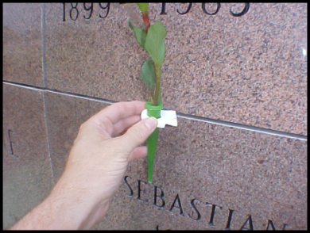

Necessity is the mother of invention. One of the author’s smart inventions. This single flower holder is designed as not to damage stone yet present the flower properly on walls in public mausoleums. To order them, see appendix B.

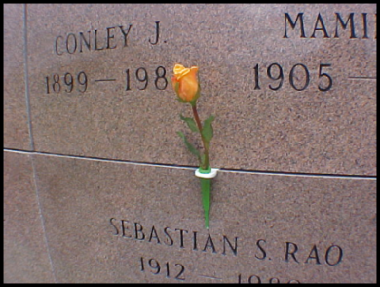

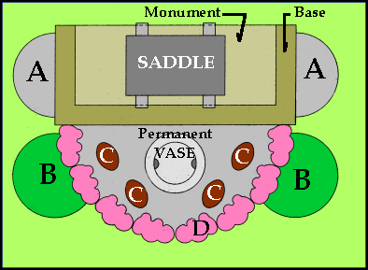
TYPICAL REGULATION LAYOUT
Looking down from above the site.
A) Area between monuments. Often you will find small shrubs growing here. Often a cemetery will prohibit any but the smallest of shrubs. Think miniature Azaleas, dwarf Junipers. Best to reserve this area for items you want to share with other visitors like cone vases, hooks, stakes and tools you won’t mind loosing.
B) Framing area. Reserve this area for tall pieces like bouquets with high standing Gladioli and palm crosses and civil emblem stakes and flags.
C) Inner circle area. Most cemeteries will allow at least 18 inches forward of the base for planting and decorating. When planting, reserve this area for mid-size plants such as Silvia, Daffodil, Geraniums and Tulips. When not planting place artificial arrangements within this area.
D) Outer ring area. Employ this area for border flowers such as Alyssum and miniature Begonias.
Permanent Vase area. Not all cemeteries will permit permanent metal vases. Especially if you cement it in place. Because any metal or rock-like substance can harm visitors and employees if the vase becomes dislodged - as when the grave is opened for more burials. However, they are common, and it is in this area where you would a metal vase or place a cone of water to display fresh cut flowers. Remember never to allow the cone to stand with water and no flowers. It will breed mosquitoes.

The Gift Occasion Guide
The short, spontaneous visit: Bring only your thoughts and perhaps a single flower.
Birthdays: A silk flower birthday cake or a bouquet with a balloon and/or endearment tag..
Anniversary of the entry into paradise: Large bouquet or flower basket add an Anniversary
In Heaven tag or Anniversary tag.
Wedding anniversary: Silk or fresh flowers with color scheme of the year celebrated. Add an
Anniversary pic.
Prayer / Wish Answered: Small fresh basket or silk arrangement with a Thank You pic.
Valentine’s Day: Dozen roses. Fresh in the tropics, artificial in the north.
St. Patrick’s Day: Something green. Artificial in colder climates.
St. Joseph’s Day: A lily or bouquet of lilies. Artificial in colder climates.
Palm Sunday: Palm.
Easter: A lily or bouquet of lilies. Chapels and specialty items and arrangements. Now
is a good time to plant hardy bushes and flowers.
Mother’s Day: Plants. Pink roses, carnations or mixed bouquets. Specialty items and
arrangements.
Dad’s Day: Silk blue colored chapels and pillows. Dad plaques are popular.
Memorial Day: Flags of nation origin and national honor.
Independence Day: Flags of national honor. A plant or small fresh or silk arrangement.
Rosh Hashanah & Yomm Kippur: Never visit on the holiday itself. Try to be at the Yartzeit –
day of burial - and bring YOUR favorite flower.
All Souls Day: Halloween is a time to celebrate the dead as a community in God or Christ or
in fashion with local family, community or tribal belief. Lots of orange and
black. Artificial in colder climates.
All Saints Day: A single rose brought after a religious observance. Most secular cemeteries
will hold observances on cemetery property. Ask at the Administration office.
Veteran’s Day: Also called Remembrance Day. Flags of nation origin and national honor.
Poppy is the flower of the day, bring one or a bouquet.
Thanksgiving: Unless it is impossible, DO NOT ignore this holiday by decorating the site
with Christmas decorations. This holiday affords you with a wonderful
assortment of decorative bouquets and pieces. Scarecrows abound!
Christmas: Is celebrated in the cemetery from December 15th until January 30th. You
should “schedule” 3 visits. The first 10 to 7 days before Christmas. Place
a Christmas blanket first. The second visit on or near the holiday. Turn the blanket
to remove snow. Bring a small decorated gift like a snowman or chapel. The
Last visit is to close out another year. A single flower is enough.

Think Before You Screw Up
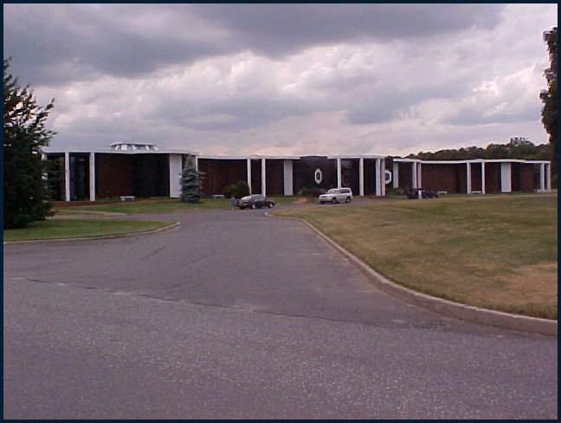
One of the largest shifts in the business of the cemetery over the last century or more is a shift in ownership. From us to them. It is not a drastic shift because ownership of graves and memorials moved logically from us to trustees to them. If you research this trend, you’ll find these shifts were mostly done to insure graves whose owners and families themselves died off, as during famines (see Irish history.) “In the olden days” cemeteries crowded the churchyard and trustees were setup to care for the entire ground. Most of these trustees are still active today, but include massive burial grounds. Bottom line is that you do not own the grave or the memorial. You do have burial rights usually forever in America (from 15 to 90 years in many European countries – a whole other book.) And, of course, if you want to modify or replace the family headstone, no one at the cemetery will object. So long as you are the original deed holder. Once the deed holder is gone, the cemetery will make the heirs jump through hoops to affect any change to ‘their’ grave and monument. This assures future visitors are guests welcomed to the park to partake of it and to allow it to remain beautiful and functional.
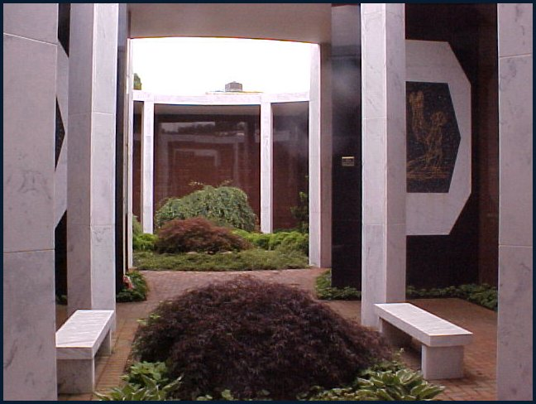
This trend is nowhere seen more readily than in the public mausoleums. These structures first appeared as the modern cemetery , with all its acreage, found itself squeezed in by a city. The oldest that I am aware of dates to the 19th century. They can be found in every large cemetery today. In many of these astounding and lovely structures visitors are not even permitted to leave gifts at all. There is no designing permitted and no epitaphs or endearments. They are big, fancy, mortuary vaults. Inside a visitor feels entombed rather than welcomed or at ease. A product and necessity to the times.
They are also convenient and sanitary, reminiscent of a chapel. So it has benefits, especially if you’re in high heels or better than street attire. Although I recommend against high heels even so; notice the floor in picture, it’s common brickwork. They are not designed by monument builders, architects get these projects and, apparently do not confer with memorialists. Not by the looks of the projects, anyway. The look and feel is functional, like a modern chapel. There is very little inspiration yet there is always lots of seating and cute little gardens. Be careful not to create trash as there are no dispensers. Expect the air temperature to be too hot during summer and remarkably crisp during winter. I will give it this: the interiors are so quiet that outside noises from trains and planes are even muffled. You can vividly hear yourself think and, if such a place can induce you toward fond memories, they’ll come through loud and clear. They transpose the cemetery from memorial garden to bodies stacked around tiny, cultured gardens. Don’t expect much inspiration when visiting these structures. And, unless you’re a ‘thoroughly modern Millie’ try to avoid even coming near these buildings.
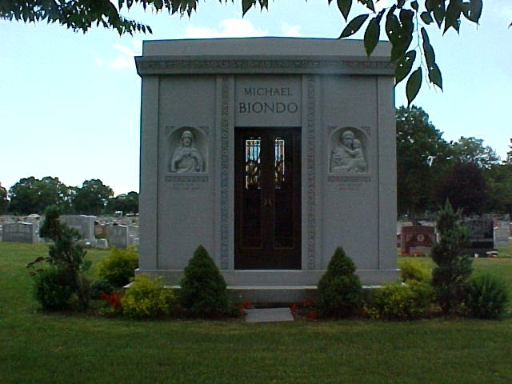
The ancestor to these structures is the private or personal mausoleum. The very first was built for Alexander The Great’s dad and is today the rich man’s very own pyramid or kingly tomb. Unlike its bigger and younger brother, these are filled with inspiration. Most are ornately designed and you get this echo from the Victorians that wealth boosts our heavenly reward - like the bucks are not good enough in the here-and-now? Very few do not excite the spiritual side of the imagination and very few are ever in danger of ruin. They are built with forever as the goal. Few are strictly functional. Not designed by architects, these are master strokes from memorial builders wherein the visitor feels not like entombed but at bedside. They are also extremely fine representations of their times. My family mausoleum, designed by my uncle Pasquale, was erected during the early 1960s when functionalism was king. Thus it looks like a box with a dramatic stained glass window. If you return to the Victorian ones, gosh! they’re elegant and over done with so much filigree that it takes hours to take them all in. The mausoleum you see above was built in 2003 and speaks to the quest for a return to classical design.
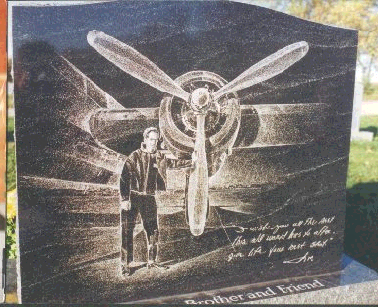
What you see here is called an etching. Usually preformed on black granite, once the polish of a stone is broken by a sharp point, it will remain like that as long as the stone exists. The art form has been around as long as dark stone has been employed. It is photographic yet uniquely artistic because it requires an etcher to create the image without blue print or tools other than a pointed object and small mallet. I post an interesting tale about etchings in Part II, don’t skip over it..This etching was preformed by Bill Peisher, of Woodburn Monuments, N.Y.

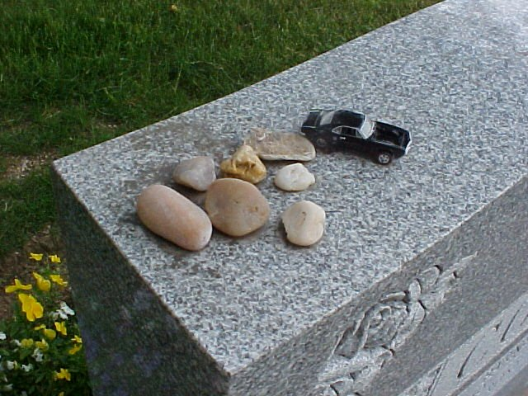
Leaving Rocks. In ancient times most graves were tumuli (singular: tumulus) a mound of earth and stones rasied over a grave(s). The idea was to protect the body from animals as well as a means to locate and identify the spot. You were expected to tend to the mound during visits and that action is carried on today through a tradition often seen at Jewish cemeteries, but almost anywhere. Stone will not hurt stone – unless struck. But paints and especially adhesives can permanently stain bronze, granite and marble surfaces. In this photo we see a child’s toy that surely touches our hearts. I imagine a child left it there as a token of his visit. A cemetery worker might (and might not) remove it. However, if left there over time the sun will melt the rubber wheels, rain will spread the paint and the top of this monument will be indelibly marked. Never affix anything at all to monuments and markers unless it is properly doled and attached by a professional.

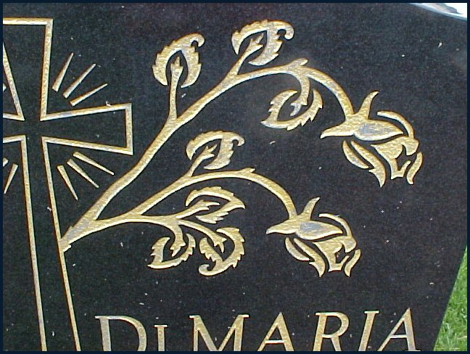
Gold leaf is a good example. I am always astounded by claims from my own industry that someone, somewhere can affix gold to stone and guarantee it will last forever. Notably, most who claim this are near the end of their career / life and greedy enough to grab the last buck that’s lying around. Most builders will gladly attach gold to stone, as long as you sign a wavier and understand it will fall out eventually. The gold leafing in the DiMaria stone shown here started to fall out before its fifth year. Stone and even bronze circulates air and moisture. Pour a bucket of water over a small monument and watch what happens. It will dry top down just like a sponge. Nothing glued or painted to stone can fasten itself forever. The water and air moving around in the stone itself will eventually undo the foreign material.

VIRTUAL VISITS

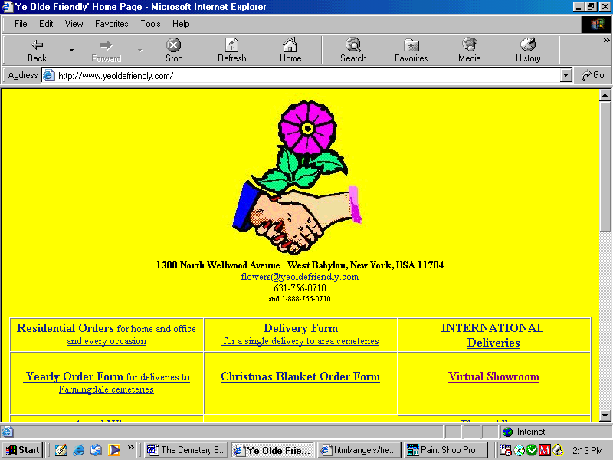

A search on the Net for ‘virtual’ cemetery’ will yield you online cemeteries from famous ones to pet cemeteries. They are handy research tools. However, they do little good when you’re stuck indoors or cannot get to your site. Or when additional work has been done to the site such as adding stone work, or engraving, or a delivery of flowers you ordered. There are solutions.
Many cemeteries, some funeral directors, a few monument builders and many flower shops post records online for public viewing. Most are secured sights and you cannot access them unless you have a password or you access the information directly at the administration office. The Veteran Cemeteries have a handy machine in their entry way where you can type in a name and not only get a list of everyone interred under that name but a map also. There is talk in the industry to link up all records thus allowing anyone from anywhere access to information regarding deeded graves, regulations, geography, and more info than I can state here. There are some hitches to overcome, but expect such services soon.
When I deliver flowers to a grave I send along a photo of my work to the customer. I then post that image as a permanent record at my florist’s website. This serves to notify the customer that the job is done, but also to allow the customer to view the condition of the site and to take a moment of mediation and reflection he or she might not had an opportunity for. As I will mention in Part II, the monument’s purpose is 3 fold. One purpose is to refresh the memory of a love one. Virtual visits perform this function very well.

A Word about Shrines

As the face of America changes we see Drive Safely signs adorned with teddy bears, flowers and artifacts. We visit the homes of friends who migrated from the Caribbean and elsewhere to discover altars with framed photographs and candles. These are shrines which commemorate more the death event than the memory of a life. It is an ancient ritual wherein people bring to a place of recollection of death the objects which still hold thoughts of life and the living. In short, it is a ritual to reward and remember Death in order to face its fear head-on and overcome that emotion. When decorating a shrine, seek out items which you shared with the deceased. These would not be gifts, rather they should be objects handled by the two of you during his or her lifetime. By doing so you share in the death event in a virtual and token – and damage free – manner.

A Word about Candles
Candles, especially vigil candles are wildly popular. Many models are made with solar or battery powered lights, and I recommend these. If you employ fire take precautions so that the flame does not touch the parts which can burn; most vigil candles are made of plastic. If using a stand-alone candle, be sure melted wax will not mar the surface of the marker or vases and decorations at the site.

Part II Enriching the Visit.
The Garden and its Rocks
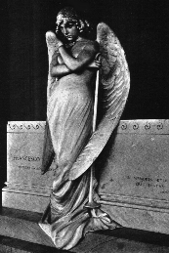
Typically, and thankfully, the memorial park is quiet and peaceful. It’s not a place to expend energy, to play, conduct business or congregate needlessly. Many steal away to enjoy their lunch breaks among the gardens and buildings, stones and fountains. I have spent several days off finishing a good book under the maple trees at Pinelawn Memorial Park, both reading and typing on a laptop; and I know I‘m not at all alone in that pleasure. Beyond doubt, especially around holidays, you will sometimes be surprised at how many people make the most of the community burial grounds.
The popular belief that suggests the present generation has scorned graveyards is a myth to anyone who visits on any holiday. Save Vet’s Day and Memorial Day. Both holidays at Vet’s cemeteries see visitors, however, making a comparison with a civilian cemetery is ridiculous. For example, of the 200,000 sites at the Long Island National cemetery, less than 15,000 of those reflect interments from the present generation. Still graves reflecting the Korean War and the World Wars can find a bouquet or two on them every so often. In major and old cemeteries people gather to visit while students, tourists and researchers are escorted on guided tours. Some famous cemeteries harbor so many tourists that a visit to a loved one’s site can be down right annoying. Some very famous burial grounds in Europe and Egypt pile on merchant booths and side shows to ridiculous extremes. It is sometimes eerie the way famous cemeteries will merge entertainment with the management of an active burial ground. Hopefully, you or yours are not fretting among the rich and famous. Instead, for your more subdued entertainment, I’ve included some inspirational verse, and a tale or two in Part III.
What most people do not gleam is that there lives an abundance of communication clamoring all around them. There is music, tales of drama and tragedy. There flows inspiration and urgency. There is gracefulness and utter despair. Calls to heavenly bliss and quiet wisdom meant for all ages in all generations. It’s right in front of you and so many, even those who take the tours at those upper-crust cemeteries, walk right by it. It’s carved directly into the rocks which fill the garden.
A monument, whether it is a simple marble, military monolith or a flush bronze marker or a small granite die squatting atop a rock-pitched base or a mighty mausoleum or a feat of immense human industry like Stone Hedge or the Taj Mahal, serves three functions. 1) It marks the site. 2) It is a legal document. And, 3) It serves to refresh the memories of the living about a life now fully completed. In the case of a civic monument it marks values and/or events, serves as a commitment of the community or society and refreshes our memories concerning an event or values expressed in the structure. The Statue of Liberty is a monument.
A grave marker, whether it be a stone, metal or natural earth formation (like a cave) often rest atop the grave and thus the earth. Landscapes and the earth below them are often fluid, as anyone who tries to build extensive piping systems on islands of sand – like Long Island, N.Y. – can attest to. Or anyone, like an archeologist, who is required to exhume ancient graves, must contend with. Modern cemeteries, therefore bury close and lay boxes head-to-head and foot-to-foot. Where an upright monument is planned, a four to five foot by two foot retaining wall is placed along and at the head of each row of graves. This serves three purposes. It economizes on space. The ‘beam’ as it is called, acts as a permanent footing for stone work, and, it locks entire sections of graves together, thus avoiding underground drift. Graves marked in today’s cemeteries are likely to remain put for thousands upon thousands of years. Because of the beam the grave markers properly serve their first function of marking a location.
The second function comes as no surprise from the far reaches of history. A grave marker is a legal document. For the longest time gravestones were called ‘ledgers’ because they recorded information about the deceased upon it. As these ledgers grew in dimension and eventually developed into a large slab atop the entire grave to ward off robbers, then evolved into the grave covering it is presently, any grave marker now serves that ancient purpose. Every court of law, all major institutions (Social Security, IRS, et al) recognize a grave stone as proof of a life now completed. Which brings more responsibility upon the cemetarian to demand that the stone cutter be exact when inscribing names, dates and sayings into the marker. Up until recently, very few cemeteries – especially secular ones – would even permit nick names or verse which might be misleading. As an example, the following are three epitaphs off three monuments found in an old cemetery in New England, USA. The first reads: John Samuel, Born 1774, and Died 1852. The second reads: Lisbeth Samuels, Born 1778, Died 1860, Wife of John Samuels. The third reads: May Hapswood, Born 1784, Died 1859, Should have been John Samuels’ Wife.
Suggestions and suppositions are tough to get carved in stone nowadays.
The third function you are employing at this very moment: the revitalizing of the fact of who this person was and all he or she meant to you. And, perhaps most importantly, though over looked, a direct statement saying that person is no more. He or she is now resigned to eternity as you have the traditional honor and rite to pay your respect to that profound mechanism of God’s law. Life divides us from the dead, a monument is the division between the living and all future life.
And a monument speaks directly and specifically to the generations not yet born.
Centuries from now, long after that much talked about end of the world comes, long after the English language is lost to time and maybe even after a long and chilly Ice Age comes and goes, that stone where you just placed a gift and offered a prayer from your hopes and faith, and reflected upon a memory or two, that marker will speak volumes. And will promise to do so from now until forever.
Would you like to be able to read it? Would you like to know what the other markers around you say? Would you like to look at an old gravestone and be able to read it? You certainly came to the right person.

First, some basics.
No saying, symbol or design in a cemetery ever succumbs to death. The single function of a grave is to store the remains either to restore it to Mother Nature, as in an earthen grave, or entomb it for future access, such in a mausoleum. It is an obligatory function which carries no meaning other than the function. Inspiration, respect, honor and remembrance are not attributes of the grave but actualizations because it represents, in fact, that the earthly existence is over, the steely bonds of this world have been broken. Therefore all treatments of it are, necessarily, words, designs, and other creations of the sublime and wonderful. If the image of the Grim Reaper is displayed its message is not one of defeat. Rather these are symbols of mankind employing the forces of death in order to gain heavenly bliss. Remember the skull and wings found on a majority of slate monoliths in the older cemeteries? They are rather badges carved into the stone to indicate that the entombed is in fact among the dead and thus in a far better world than we are in.
Etchings, mounted photos, and carved likeness of the interred are memory joggers and cultural statements. They serve you to remember. They serve the future as a record of cultural circumstance – especially after all these CD’s and DVD’s fade away.
There are 4 languages employed on markers. The first is native, such as English or Spanish, etc. The second is the medium, such as granite, metal, glass, etc. The third is sign and the fourth is symbol.
The text carved into a marker is, of course, in the language used by those who have invested in the marker. The font – style of the lettering – usually is standard Roman Modified or Script. Both are common commemorative fonts. Different styles indicate a statement of one kind of another – more about lettering later.
The medium employed to construct the marker speaks volumes. Remember when the marker was originally ordered? The salesman spoke of “Select Granite” or “processed bronze” or “standard military issue.” These tell future investigators where, how and when the marker came to be. It tells you the class, qualifications and durability of the marker. Select granite is forever, military issue will eventually fall victim to the forces of environment. Color choice of material will indicate cultural sophistication and, often, the location of the source of material. 20th century gray stone came from eastern American quarries, red to Midwestern America and Eastern Europe, black had variations from America, Africa, India and China, pink ran from Vermont and into Canada. Presently these sources still are active but, like most everything else, all colors come from China and India.
In nature, we find patterns, designs and structures that inevitably follow geometrical archetypes. Known as Sacred Geometry, designers employ these patterns in order to send messages across far stretches of time.
This is a sign: A depiction of Jesus as Lord and the founder of Christianity.
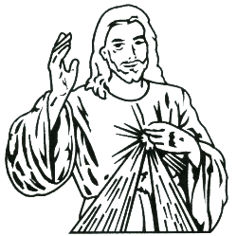 A sign of the Sacred Heart, Jesus, Christianity. Signs point at people, places and things without regard to what those things mean. A sign is a badge of identification.
This is a symbol: A symbol of Jesus, the Sacrificial Lamb of God, Lord and the founder of Christianity.
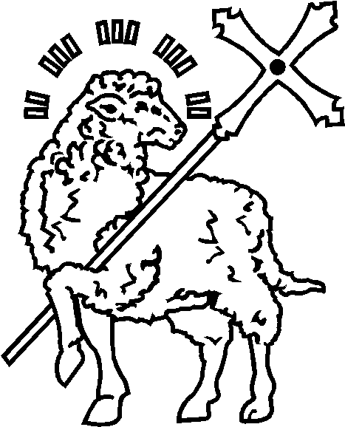 Symbols convey the meaning of people, places and things. As such, they are communication devices that open dialog between present changing reality and infinite, unchanging truths. Their potent value is to build a bridge from time past, through the present, and into the future. Memorial symbolism is an ancient art that has not varied since its first appearances at New Grange, Egypt, Babylon and before. Styles and variations have emerged, however, they proceed according to a strict inner spiritual code. For example, the cross has always been the symbol of male and female energy standing between the forces of the heavens and the earth. Variations of it now represent the Church – a community of men and women who work collectively to reconcile the forces of heaven and earth. Include some Celtic knot work into the cross and it represents the Christian views professed by the Celts, 2,500 BC through the present. Make that knot work a continuous tri-fold, called a Celtic Triple Drop, and it represents the three forces of nature...earth, fire and water under the control or in opposition of the human community. The single continuous line in a Celtic curl symbolizes the church as a unit as well as completeness of spirit and being.

 | The Broken Bud is an obvious symbol for being taken before reaching one’s prime. It is not representative of or appropriate for a child. Rather it is employed for those who formulated goals and dreams but now must complete their destiny beyond the steely bonds of earth; or leave them for another to fulfill.
  Candles and flames are symbols for enlightenment. Usually employed to indicate a teacher, but is found on markers of educators in any context. Rabbi, a learned inventor or entrepreneur, one who has brought the gift of wisdom and knowledge to a family or group. | 
The Oak leaf is an ancient symbol for inner strength and endurance. When acorns are present, as you see here, it indicates expected good fortune bestowed upon future generations. |  | 
   | The Luck Symbol takes on added meaning when carved in stone or applied to bronze markers. Naturally, it relates Irish ancestry. Religiously a shamrock is the symbol of the Holy Trinity. When standing straight it is a sign of male fortitude. Turned as you see it here is indicative of female beauty.

To read a memorial properly one needs a level of understanding of the symbolic language used. There exists an endless list of symbols and signs, far too many to offer you here. However, I will try to present throughout this section the more common and how they are employed. Besides direct text, symbols and signs, emblems are frequently found carved or attached to markers. Emblems themselves incorporate symbols to create a sign or logo for an organization or group. There is no need to cover them in this context as most emblems are easily read and recognized.

 DAISY - Innocence, Loyal Love, I'll Never Tell, Purity
IVY- Faithful to the end, Friendship 
 ORCHID - Beauty, Refinement, Chinese Symbol for Many Children

Reading Monuments

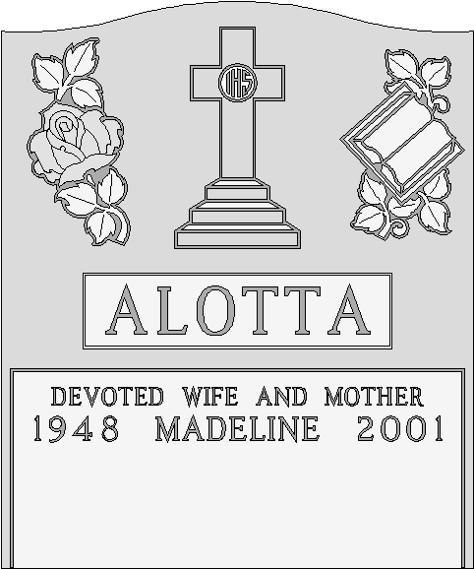

The usual reason to read a monument is to find a grave. However, once you found the site and now want to listen to what the stone at the site and others around you have to say, you should pull back from seeking a name or section numbers. To read a monument, such as the ALOTTA monument, we begin with the material and the shape.

The monument is made of gray granite. Which tells us this is a serious placement set to remain for eternity. It has a polished finish which indicates refinement, dignity. Polished stone also indicates inner strength because the closed (polished) surface forms a barrier against mildew, sap and settled water residue.
The shape is tablature with a serpentine top. Like a pillar it stands erect, proud and is meant to be read like a book. Above all else – at the top – no matter how immovable this granite might be, how dense and tough the stone, a ‘serp’ top indicates the determination of the human creative forces needed to cut hard stone. The sweep of the ‘serp’ is a symbol of the freedom of the spiritual being that can now move in any fashion desired, unrestricted by natural forces.

The surname is predominant and sets the eye. A good designer will bring your focus to the beginning statement of the stone’s revelation. Enlarging the surname, placing it in a whitened panel (called a steeled panel because it is whitened by spraying the polished stone with a steel shot) positioning the surname as closely as possible to the stone’s center and employing it to separate the design work from the lettering, your eye naturally rests and starts at this location.

Thus begins the message carved in durable rock, fashioned by modern technology: We wish to tell the story about a member of the Alotta family, Madeline by name, born during the year 1948 and died during 2001, a wife and a mother who was beloved and remembered. As it is natural for the eye to drop while reading, it is just as natural for us to raise our eyes back up to the design work when reading is stalled. Coming directly up we encounter a Christian symbol. There are 3 steps leading to the cross which represent the three virtues, faith, hope and charity. It is through these virtues that we climb the path through the church and eventually find Christ –the HIS- in the nimbus or, as it is better known as, halo. Thus, this is a Catholic memorial. Madeline was a baptized Catholic. A designer can not predict if your eye will move to the left, as is the case for most left-to-right readers, or to the right. However, there are two memories this designer cares to relate concerning Madeline and the Alotta family. On the left is a carved rose. It is big and very deeply carved. A rose like this in stone is a symbol of very deep and committed love like that shared between a married couple. Above and below the rose are leaves in sets of three. This, in a Catholic setting indicates the Holy Trinity. But with a twist. Notice the top pair of leaves, pay attention as to how the points of each leaf is facing. If you allow your eye to flow with the top three points you will move in a circular fashion. The leaves form a circle, a bold statement that there are three persons alive, moving and visible in this trinity. The Alotta family (or at least their designer) is carrying on quite a religious conversation. Now look at the bottom set of leaves. Your eye can not form the circle because one point stops you. Instead you form a triangle. In this setting the triangle represents the Trinity as the all-knowing God of the Bible. The Alotta family loves deeply and profoundly. Madeline, her husband and family were (and still are) very lucky and loving people. And there’s more to them. On the right the story of the Trinity rests in the background to a book. It is not a large, imposing book so we ought not think it the Bible. Rather it shows education. Perhaps founded and resting upon Catholic teaching, but learning nevertheless. This family values love and education as tools to gain oneness with Jesus through the teachings and practices of the Holy Mother Church. The suggestion that her place in heaven is assured, seems obvious.
The entire focus and message is one of life, spirituality, and about the rewards promised to those who uphold virtue. The Grim Reaper often rattles our foundations, yet can not break our bonds with immortality.

Epitaphs and Endearments are two different sayings. The line BELOVED WIFE AND MOTHER found on the Alotta monument is not an epitaph. It is called an endearment. An endearment addresses individuals; usually in an ‘endearing’ fashion. To Know Him Was To Love Him, Beloved Son, Kind And Good Doctor, are all endearments. They revitalize your memory of the loved one. Epitaphs make declarations. They are final words on the matter. In God’s Care, Always In Our Hearts, We Mourn and Lament Our Brave Youth, Rest In Peace, are all declarations about our encounters with mortality. The Alotta family did not carve into their stone an epitaph. Why not? Because at this time only Madeline lies here. The Alotta story is not finished. Most graves have room for at least three interments. The Alottas apparently feel that a declaration at this time would be premature. When another or the final name is inscribed, then this educated family will say their piece.
I have included some interesting epitaphs and endearments in appendix C.

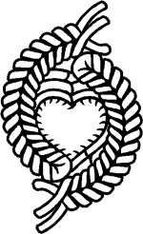  by permission from Bill Peisher, Woodburn Monuments | The Labyrinth, mazes, knotted rope, wandering threads are very ancient symbols of how mankind is framed by the grip of time. The twisting and turning paths all lead to the center, to the womb wherein, through sincere effort and the endurance of time, each of us returns to our maker. Usually the center image depicts God in the shape of a circle, a set of circles or a square. If not God then some lofty and often unobtainable ambition is depicted. They are often found on markers if you know what to look for. Here on the left you find two strands of knotted rope set about a heart in a Tai Chi (Ying Yang) formation. The edge of the heart is serrated to indicate a stormy but heartfelt romance. The Tai Chi layout is of mirror-like ropes to bring home the message that these two were of the same mind and reaching for the very same feelings of love; both employed opposite methods and means.  Scroll work shows opposing forces which form unity as illustrated below. Thanks to Derick Earp.

The Tale of the Talty Family

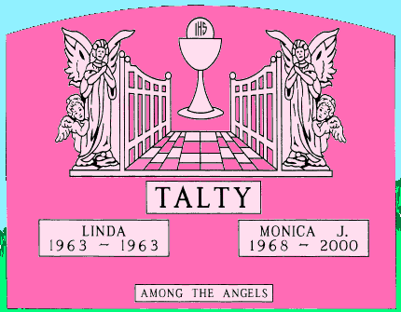
I had the honor but staggering experience of designing the DeFeo monument – of Amityville Horror fame – when I was in my early twenties. At the time I thought I’d never come across such sadness; memorial designers do so often. Here’s a sad story which begins in tragedy and turns blissfully to triumph. I’m not one to believe in reincarnation or one who would profess the notion on a stone in a Catholic (anti-reincarnation) cemetery, yet that is exactly what I did for the Talty family. They believed their Linda was reincarnated as Monica 5 years after Linda died. When Monica left for the gates of heaven at a young age also, Mr&Mrs. Talty became convinced.
We begin our reading again with the material and shape. This stone is pink granite, the softest of all granites. Appropriately pink because the Talty family consists of 3 females and one male. The oval shape is completely indicative of the bow of heaven where the entire story is told. Taking in the surname then moving to individual names, we are astonished to learn Linda died at birth (actually within her first year.) Then comes Monica in 1968, who returns to her maker in 2000. The epitaph – Among The Angels – is a clue as to what the parents are trying to tell us. Looking up we find a large chalice with the sacred host, the symbol of Jesus. Whenever you see a chalice in a Christian setting it speaks directly of the agony Jesus experienced in the Garden of Gethsemane. However, if a host is shown, as above, the symbolism changes to mean the Mystical Body of Christ. Again, this stone is hinting that there’s a hidden meaning. The chalice now means Transfiguration and it stands exalted within the open gates of heaven. This further confuses us because the Transfiguration of Christ is not something we gain as humans, whether we climb the path to heaven’s gates or not. Usually, this design will hold a cross between the gates, affixed to the pathway as a sign of entering paradise through the virtue of Mother Church. Instead we have the unobtainable. I can hear an angel saying, “Linda is not here.”
And where is she? She is hiding, obviously. Behind her big sister Monica. Linda was transfigured (reincarnated) as Monica and now is one angel aside the gates of heaven awaiting reunion with her parents.

Here’s a design fresh off my computer. Begin reading at center…….
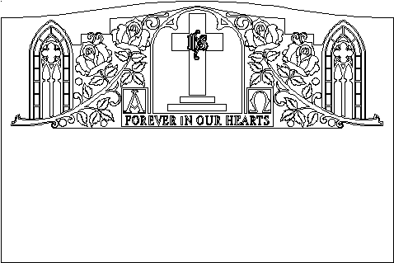
Our faith burns forever in our hearts, that through the adherence to faith, hope and charity we obtain the (chapel) embrace of Mother Church our salvation (the cross) and reunion with Christ (IHS.) This is for all time (Alpha - Omega.) Built around our faith is our great earthly love for family (4 deep roses expressing deep love usually reserved for married couples. Surrounded by many leaves shows a love for family.) Affirming and standing guard is our personal honor and dignity which is reflected by a civil and scholarly introspective (the side chapels.) All this is engraved within solid granite which will endure all forces forever."
A Roadway To Heaven
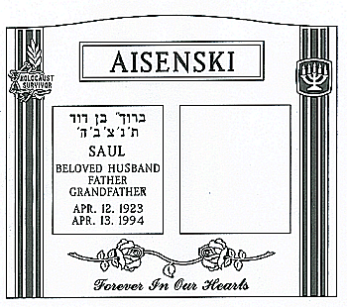
An easy read. The Aisenski monument is completely devoted to two people very much in love with each other and with their God. The stone is large and formidable. Saul lived a long and rewarding life, and enjoyed grand children. The expression of love we see here of two very deeply carved roses, one for Saul and one for his widow, come together in a single thought –as a single leaf – which points at the epitaph. A saying so dear and simple.
Open top (soaring) columns are a symbol of the tie between heaven and earth. Like a ladder, a roadway ascending into heaven. A column’s reach is limited solely by imagination or human resource. These columns span the entire height of the stone and suggest an inspired, further reach. Two pillars represent the duality resolved by the pathway between them and leading into a new life. This monument is for two people in one spirit.
We also see that Saul’s life endured profound suffering during his early years. The Holocaust Survivor emblem is a dreadful reminder of man’s inhumanity to man. That the designer chose to place it on the column infers remarkable acceptance by Saul and the entire Aisenski family of mankind’s situation. It is saying that suffering is very much a part of the human quest to gain a place in the kingdom of God.

An Unfortunate Read
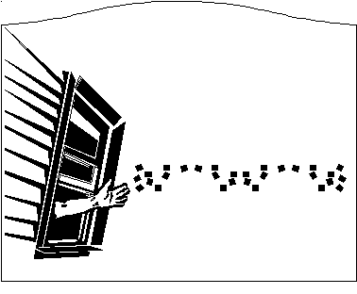
At the archive I’ve founded and administrate, we have an option called the Wish List. Designers in need of a design they either just don’t have the time to draw or are at a loss of expression will submit a project to all the other designers who are members at the Board. This project had the contributor perplexed and his project was for a man who had slowly lost his mind in the last years of living. His last months were spent sitting at a window and tearing paper up into little piles. The position of the hand is to symbolize both reaching and throwing. Reaching, appealing for a “hand” into a better world.

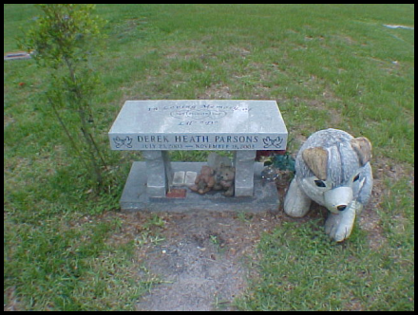
A Boy and His Dog. This concept is remarkable because the monument is interactive. Sit on the bench and you are transported to an event that actually took place. You take the place of the boy whom this work of art remembers, designed from a photo of the boy and his dog. It is further remarkable because of the inlaid black and dark red granite for the pet’s eyes, nose and ears. It is very apparent from the worn path leading to the monument that what the designer intended will repeatedly occur forever.

More Words From Designs
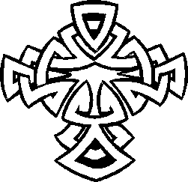
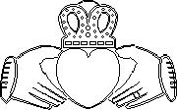
Nothing says Irish than a Celtic cross or a Claddaugh. You may carve a Latin cross or a pair of wedding rings on any monument and they say what they mean. But when it comes to base ethnic symbols – especially Irish – a shamrock, Celtic cross or Claddaugh just make no sense in anything but an Irish setting. What the interwoven designs represent is a topic for tomes and can not be covered here. The Irish hold one of mankind’s longest traditions of dignified burial rites. Many of the designs you find on distinctly Irish monuments speak a language millennia old.

Celtic cross by permission from Kimon Brown



Pillar & Trees: A generic symbol if ever there was one. In almost all traditions a pillar symbolizes what the tree had in primitive thought - the cosmic buttress, the heavenly support, the fortification on all levels. It is a symbol of strength and guidance. During daylight the Lord appeared to the wandering Israelites in the desert as a pillar of cloud to lead them toward the Promised Land. At night a pillar of fire served them with light.(Ex. 13:21-22) In 1 Kings 7:15-22, Solomon erects two pillars named Joachim and Boaz, at the entrance to his famed Temple. Two pillars represent the duality resolved by the pathway between them and leading into a new life.
By permission from Moses Lietz

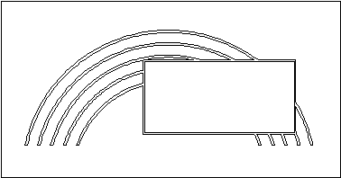
Rainbow: A rainbow is a roadway which reaches into heaven and returns to earth. A visual and psychological connection between heaven and earth, but, above all, it is the symbol of reconciliation between Noah and God - and presumably all mankind. "I set my ribbon in the cloud, and it shall be a sign of the covenant between me and the earth." (Gen. 9:13)

Rosary: The standard rosary, known as the mystic rose garden of the Virgin Mary is 150 beads divided into groups of 10 by 15 larger beads. Each one third or five decades is called a chaplet and recalls five of the fifteen Mysteries of the Rosary. Each Mystery is an episode from the life of Jesus and the Virgin Mary. They are: 1) The Joyful Mysteries: The Annunciation of Mary: the Visitation of the Angel Gabriel to the Virgin; the Nativity; the Presentation of Jesus at the Temple; the Finding of Jesus at the Temple (remember he was lost to his parents while talking to the Rabbis). 2) The Sorrowful Mysteries: the Agony in the Garden; the Scourging of Jesus; the Crown of thorns; the Way of the Cross; the Crucifixion. 3) The Glorious Mysteries: the Resurrection; the Ascension; the Decent of the Holy Spirit; the Assumption and Coronation of the Blessed Virgin Mary.

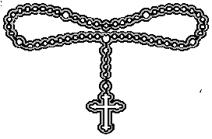

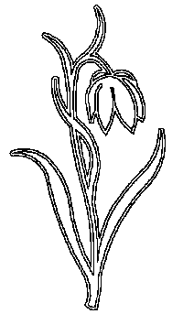 | Lily: The white Madonna Lily is the symbol of the state of purity and chastity of the Virgin Mary. But don't fall back on that too much. The lily can be seen in the arms of St. Joe - and not because Mary should be there also - as well as along side several other Saints and emblems as well. View the lily as a symbol of purity. Purity need not harbor chastity, yet it often implies it. For example in almost every painting of the Archangel Gabriel, God's heavenly messenger, you'll find a lily. Which denotes, of course, that what Gabriel says is 'straight and true.'
 | Vesica piscis: Also known as Mandorla is the elongated almond-shape formed by 2 intersecting circles. The circles depict heaven and earth |  | 
 |  | ChiRho: Medieval monogram of Christ, sometimes spoken of as the chirho, because it is a combination of these two letters X P.  Butterfly: The Resurrection for all the obvious reasons: because it emerges from a chrysalis and subsequently takes flight. |  | 
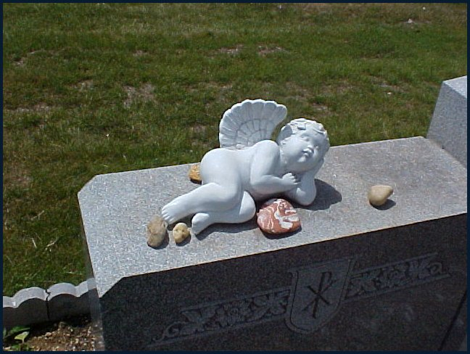
Angels can be a tough read. The original meaning of the word and the sign is THE ONE SENT. In short, a messenger. From there designers and people in general have created an entire flock of these messengers from God; we even give them wings. There are Archangels, Seraphims, Cherbims, cupids, and all kinds from those with cute bellies to those with horns on their heads. We saw on the Talty monument, the messenger is none other than the departed. Unless a designer is specific, as I was on the Talty monument, always assume that a message is within the design. Unless, of course, I come across one of those lovely little sleeping angels people attach to markers. Then, I just smile.

The number of man. 5 senses, 5 wounds of Christ.
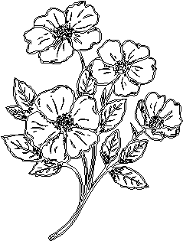
Rosettes are favorite, thus over done, symbols and signs. Having five pedals they are a sign of mankind (head, arms and legs extended) and a sign of the crucifixion of Christ. As a symbol it represents wholeness in a holistic manner. 5 is a sacred number and a rosette should always be drawn with 5 pedals (8 pedals represents the Rosetta Stone symbol) . However, with all this ado, only consider it in its symbolic fashion if it is a predominant image on a marker. You will rarely ever see it alone. Designers employ rosettes to express and differentiate between passionate love and family/friendship love. A marker offering a carved bouquet showing two roses and three rosettes might mean a family with three children and two loving parents.
Rosette spray by permission from Moses Lietz


Anchors: A traditional symbol of steadfast safety.
In Christendom as in Hebrews 6:19, the anchor symbolizes the assurance that Jesus has given all mankind salvation. We have this hope as an anchor for the soul, firm and secure. It enters the inner sanctuary behind the curtain, where Jesus, who went before us, has entered on our behalf. He has become a high priest forever, in the order of Melchizedek. (Hebrews 6:19). When the anchor is combined with the Dolphin it represents Christ on the cross. When the men had hoisted it aboard, they passed ropes under the ship itself to hold it together. Fearing that they would run aground on the sandbars of Syrtis, they lowered the sea anchor and let the ship be driven along.(Acts 27:17) Fearing that we would be dashed against the rocks, they dropped four anchors from the stern and prayed for daylight. (acts 27:29)

Anchor by permission from Kimon Brown.

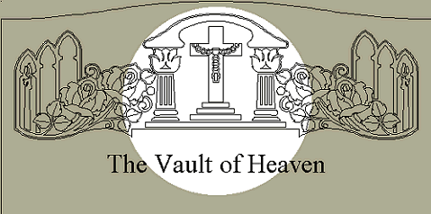

The sweep of the ‘serp’ is a symbol of spiritual freedom, when you find an arch, a bow or any curved housing enclosing a central design as it encloses this cross and creates a chapel effect, it represents the vault of heaven. Here we show pillars supporting the vault. The pillars stand aside the cross and rosary atop the three virtues. Therefore this design says vividly that through constant prayer our faith grows more spiritually and stronger day by day. Our faith, like the strength of Atlas holds up the heavenly domain.

Hold These Truths To Be Self Evident

 | Like emblems, some images need no explanation. Many people live and die by the  Law.  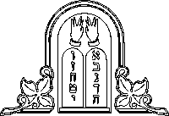 | 

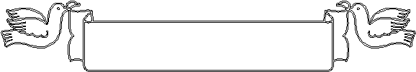
by permission from Bill Peisher, Woodburn Monuments

Doves: An international symbol for peace, doves hold a unique place in Christendom. Like angels which are messengers of God, and are always a messenger of God, the dove represents the Holy Spirit in all and any depictions. It shows several times throughout the Bible but whether carrying an olive branch to Noah after the Flood or appearing as a flaming Columbine to the apostles at Pentecost or as a snow white dove to Mary during the Incarnation, and to St. Ann at the Annunciation or before John the Baptist and Christ Himself as a direct message from God the Father, the dove is the logo/sign of the third person of the Trinity.


Grapes are transformed into wine. The obvious symbol for the transformation of Christ's blood into wine (food) for his flock. When you employ grapes into your design in a generic setting you convey the thirst quenching 'juiciness' of the fruit. Bring the design to stone or to stain glass and you speak of man's spiritual transformation. Add to the design a cross to make specific the transfiguration of Christ. Add a chalice (or Grail) into the design and the image is specific to the Eucharist. Remember the chalice alone is not the symbol of transformation.
Grapes are very often employed to count family members. For legal reasons I cannot reproduce a design I had done a number of years back that held six bunches of grapes. Each bunch draped over a frame containing the names of each separate though related family group. Each bunch totaled the number of family members; both surviving and departed.

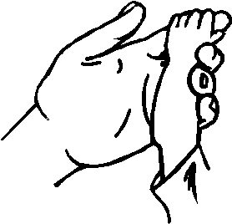
Hands hold an innumerable amount of meaning. Usually their meaning strikes out at you. An open hand held to your face is a STOP sign. Add some rays to the same hand, it is the Hand Of God. Because of this a designer is free to simply create a good drawing and expect the builder to carve it as drawn. Modern monuments are fairly simple to build – although they still are hard and heavy, even the average bronze marker. Bronze is cast to moulds and stone is sandblasted from cut stencil. The design is plotted by computer then cut by a stencil cutting machine. The stencil is then glued to the stone and then processed by a series of sandblasting techniques – steeling, shaping, bluing, etc.
A good design does not need explanation. Good designs become symbols and signs apparently on their own. Witness these two hands by permission from Bill Peisher, Woodburn Monuments.

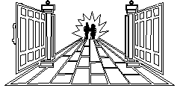
The gate or gateway is so popular in stone design that it is common. The gate shares the symbolism of the Door - as Christ is the 'door.' But, as many a monument will show you, we lean more toward Mary than Jesus. The Virgin Mary is known as the 'gate of heaven.' Mary is also called the porta clausa, 'the outer gate of the sanctuary, which faces east; and it was shut and we often draw a key attached to the left gate to symbolize this .... ‘for the Lord, the God of Isreal, has entered by it; therefore it shall remain shut. Only the prince (Christ) may sit in it...' (Ezekiel 44:1-3) The gate depicts the entrance to a new life within this life and/or the next. 'Enter by the narrow gate...(Matt 7:13) … As an antidote: when I was back there in seminary school - studying to be ordained as a Brother of the Order of the Sacred Heart - before I discovered girls, that is - a one Brother Regis told his students that if we prayed to the Virgin Mary and lead a life of sin; not to worry. Even if Jesus closed the gates of heaven to us, Mary would open all the windows for us. I sure hope Brother Regis was right.

Lettering; More Than Meets The Eye
You will never come across a gravestone without lettering on it unless it is a pre-need – a stone awaiting lettering - or a grave of unknown contents or a secular grave such as that of a priest, brother or nun. Not to identify a grave defeats it’s symbolism. It serves to submit fully to the Grim Reaper. It says that we are nothing, never were anything or any person, and nothing within the world of humanity has significance. In short, an unmarked grave is a lie.
To record the contents and to offer clarity to the message of a monument, lettering is the foremost medium. From time immemorial until just very recently, the method for cutting lettering into all stone was called V-cut. This is a chisel fashioned cut. If you place a chisel to stone and tap it with a mallet the cut produced is in the shape of a V. Variations of this V have been employed to create diversification. Raised, square, V and counter-sunk; you can count them on four fingers, yet until the advent of sandblasting in the 20th century, the V was all we had. Now it’s how much imagination we can muster that cuts lettering into stone and bonds it to bronze. For old-time sake the term V-cut remains and speaks more to the depth of the letter, not the manufacture of it.
Along with this revolution both in lettering design and computer font applications, fonts, the computer style letters such as raster and vector, presently offer families and their designers unlimited forms of expression. The age-old Roman Modified text will remain with us because of its beauty, but variations of it as well as new text forms are appearing all over our cemeteries.
It is impossible for me to offer you more than a handful of lettering styles, so I will post the more common. A search on the Internet can yield a treasure trove.
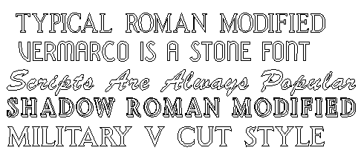
The style of the lettering can enhance the message of a memorial or it can distract from it. An interesting letter form is delightful to come across.

Time To Go Home Now
Like all gardens and parks, this is a place to linger not to over due your stay – or welcome. This place is the perfect escape from the daily grind. It’s lovely, quiet, and peaceful and the eternal residence of someone you once knew. The entire purpose of the visit comes packaged as the trip, the memories invoked, and the honor paid. The Bible says, there is no thought in the grave. That’s true, and there is no spirit there either. Nature has claimed her own and She has a time clock running on you as well. It’s time to get back to the hustle and bustle outside the garden gate. We’ll all get an eternity to lie around once our jobs are completed. But now leave such thoughts right here. What you’re fate will be, if others will visit your grave, heaven or hell? Go! get back into life. And when it gets to be all too much again, come visit the garden where the one you miss is forever.
If you bring along this book with you when you visit a day will come when you will have read cover to cover and experienced a visit as it should be conducted; many times in fact. When that day arrives and your copy of this guide is well worn, perhaps you ought to pass the book onto another and reduce your visits to holidays and anniversaries. In my trade we never ever say good-bye to people. You will be back. Next time, however, the dread and awkwardness will not accompany you.

"Show me the manner in which a nation cares for its dead and I will measure with mathematical exactness the tender mercies of its people, their respect for the laws of the land, and their loyalty of high ideals."
William Ewart. Gladstone (1808-98)
British Prime Minister
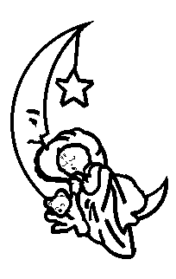
By permission from Pete Mamorato, Art Stone Memorials

Part III – Cemetery Reading
I opened Part II with mention as to how busy an active burial ground can be. A cemetery is, essentially a park. Spending time to take in the atmosphere is worthwhile. Taking time to just sit and be close to nature and a beloved should have a great healing effect.
To aid in this endeavor I have compiled for you some short stories, poetry and art. I hope you enjoy them.



Fingers of Nature
Bring your mind fingers of Mother Nature.
Softly I will worship you with these flowers.
Hour by hour.

Floating over the valleys of your memory.
I will collect the sweet sands from your sea.
Gently I will offer you soft, delicate flowers.
Hour by hour.

Flowers that softly touch with each touch one gives.
Flowers that are for our cause, our love, make it live.
Gracefully I will stretch out before you multi-colored flowers.
Hour by hour.

Bring your mind to an ocean of drifting finger-like flowers.
Float your heart between waves of overwhelming flowers.
To live is to be with you forever in multi-colored flowers.
Hours upon hours.

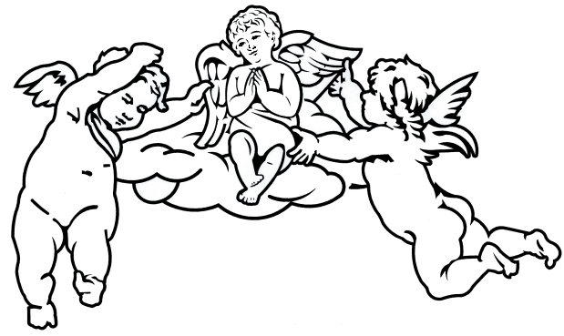

Some say life is but a cherry,
Some say it's but nothing at all.
Some find life in all that's buried,
Others hang them on the wall.

And the way that we are merry,
And the way we forgot to share
All those play toys on the ferry,
All the ones left at the fair.

They say the soul is pure in Constance,
Others speak but get nowhere.
Others say there is no such Constance,
Others speak but get no ware.

But I'm sure there is a pathway
Leading from here up to the stars.
But I'll wonder when we're halfway,
What of all the wasteful scars?

All those people who dreamed of wonders,
All those who dreamed at all-
Some have lived only in blunder,
Others lived not at all.

And the scars which man does carry,
When they're laid down at last-
Will one face reflect the marry
Of the present to the past?

The Lord spoke
and she was stricken from me.
Helpless limbs as branches on a tree,
one silence
and she was taken softly from me.

The needlework of younger days
fell somehow loosely apart.
And picture frames held by stays
talk some words to my heart.

A tapestry of gold and white
sigh circles around my heart.
Glorious stars of the night
remind me we're apart.

Whose majesty can pry this way
and draft out all our lives?
What suffering is this we pay,
a tribute to end our lives?

The Lord spoke.
Pray death is well to meet.
Pray heaven is long and sweet.

You Knew This Was Coming, Didn’t You?

My Ghost Story

Spring, 1965, I finally had my driver’s license at age 16 and enjoyed my role as gofer around my Dad’s monument builder’s shop. Since age 12, I lived a boring existence moving from home to school then, after school, to a back room with not much else but a drawing board, then back home again. Carried back and forth by Mom’s taxi or on foot. Being a gofer with a new set of wheels came as a step-up in life!
Dad came to me, on this fateful day, and handed me a roll of rubbing paper. This is a wax-coated blue film that a designer will lay across the face of a monument and rub away the wax to leave behind an exact image of the craving from the stone. It is used when duplicating a design or, as on that day, to copy the layout of an existing monument so a stonecutter can come along later to engrave additional lettering to. A draftsperson (me at that time) would take the transfer and create a blueprint for the cutter.
I drove my 60’ Bonneville to a small church cemetery on Broad Hollow Road in Huntington. Today it is better known as the Route 110 corridor and busy as all get-up. But the small ‘Jesus Saves’ church and graveyard are still there. So I’m going to change names as not to have too many people staking out a ghost hunt at the tiny location. I came upon the GREY monument not too easily as it was an overgrown site, a very old stone. As I started rubbing a small voice asked. “What are you doing, sonny?” I looked back to find an old women peering down at me. I stood and explained myself with all the pride and confidence of a teenager. She was so kind and interested, also amused. She explained that this was her husband’s grave and that she did not like others fussing with it. I did not comment on her poor job of tending to it. Instead, I proudly continued my job while she chatted about her husband, their children, a local general store I never heard of and how she missed the ‘by-gone days,’ as she called them. I finished and we exchanged a few more niceties. She wished me well with school and work then I left for my car.
To get to my car I needed to cross a driveway leading into the church’s garage. I was stopped because the pastor and about 7 others appeared from the garage. They were leaving a choir practice and our paths crossed. While moving past me, the pastor asked what I was doing. I told him and mentioned the nice old lady. “Oh, Mrs. Grey,” he chuckled. This caused both a stir and laughter among them. I, of course, stood wondering why, when one of the people said, “We all know Mrs. Grey, she’s been dead for almost 30 years now. And still holds vigil to her husband’s grave.”

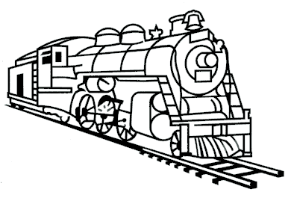
Going away from here,
Leaving without a tear.
Things may seem so gray,
until another day.
So I will journey from here
leaving without a tear.
My bags are packed for good
to stay? I never would.
The days, they seem so long,
the nights, they seem so wrong.
My bags are packed for good,
to stay? I never would.
Mary, I'm leaving you.
Johnny, won't make you blue.
No more dances to attend.
No more jobs to mend.
Mary, I'm leaving now;
you'll get along somehow.
So I got on the train
rolling on thru the rain,
Then I thought of the town
leaving with engine sounds.
So I got off the train
walked back home with the rain.


The Taj Mahal.
Not all monuments are built, and not all built by man. Some are eloquent parts of the planet like parks. Some are natural formations, which tell a story so vividly that a child can visualize the event, like a meteorite crater. But for the most part, it is up to us humans to assemble lasting materials together in order to speak to future generations and tell our story. And perhaps the most beautiful story and the most beautiful monument of them all is the Taj Mahal. The Taj Mahal represents the high point of Mogul architecture. In 1631 the wife of the Mogul emperor of India died giving birth to her 14th child. She was 36 years old and had been married for 18 years. Her Husband, Shah Jehran, had lost not only his beloved wife but also a shrewd political adviser and is said to have been in mourning for two years. He vowed to build a tomb worthy of his wife's memory, something utterly without equal anywhere in the world, and few would deny that he succeeded.
Arjumand Banu, otherwise known as Mumtaz Mahal ("the Chosen One of the Palace") has as her memorial an astonishing building which bears the abbreviation
of her name: Taj Mahal. So many superlatives have been used to describe this monument that almost everyone who visits it expects to be disappointed. No one ever is. Besides the sheer majesty of the monument is the power of the love Shah Jehran held deeply for his wife. And there is one other point, over looked by laymen; everyone knows the story, sees the monument, knows who ordered it built, but the architects are completely unknown. It is often said in the stone trades that the Taj Mahal was history's monument to the modern age. An age more personal than before, more sincerity between the sexes and more focused on the art of things than the artists.

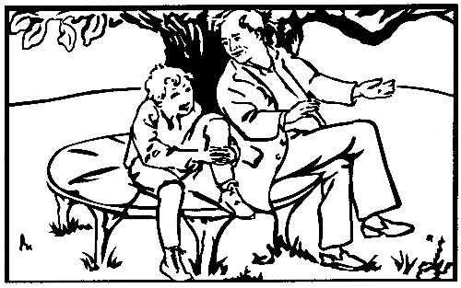
Drawing by Moses Lietz
An Old Man’s Whistle

How does the whistle of an old man prey
the memories gone day by day.
Whistle no tune or pattern at all;
Just a song for his season at fall.
Every exhale brings into mind
a once forgotten lovely time.
The macabre display of life gone short,
The array of battles won and fought.
How does the whistle on an old man prey?
Deep into his mind a love gone away?.
Life is this to the whistler now.
Life is all but a whistle, somehow.

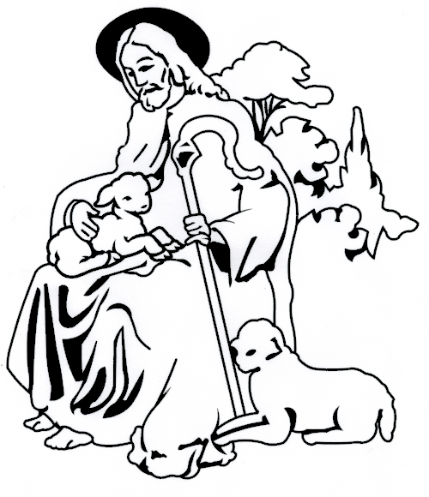

Have I forgotten the Lord, Jesus, has walked thru here?
Or has it been such a lengthy time that it is hard to remember?
Rose high His hand and smiled at me.
Lifted up His head and spoke to me.
Have I forgotten that the Lord, Jesus, is not so far away?
Or is it such a distance that it is hard for me to see?
Sat on a rock and touched my hand;
removed my youth and made me a man.
No, I have not forgotten all that.
The dust of time may antique it,
and the streamers of nations somehow alter it,
and the thundering sounds of progress hide it.
But I remember.

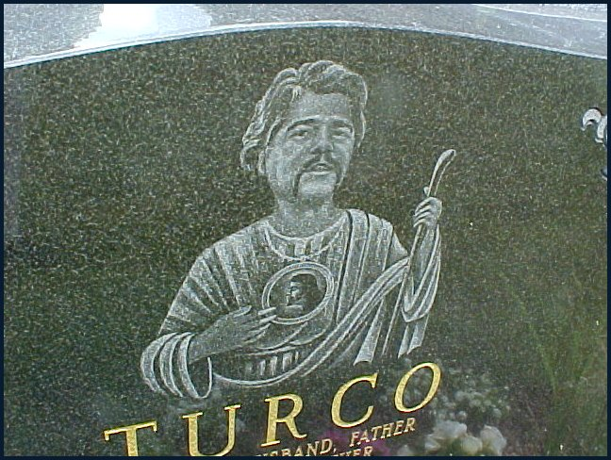

This is not St. Jude

When my dearest friend Artie Turco died in 1996, the cemetery he was interred in did not permit personal identifiable images on stones. His family naturally turned to me for the building of his monument and asked how I could carve Artie’s image around the cemetery rules. My method, shown above, is Artie’s favorite saint – Saint Jude – but with Artie’s head. St. Jude is always depicted with a flame above his head, my “forgetting” to etch it upon this stone was done to inform visitors that this is not St. Jude.
No sooner had word got around about my little trick than everyone started doing the same (although I had been skirting rules since day one.) Below is an angel with her hair formed as a halo not from my drawing board, but definitely one with my spirit.
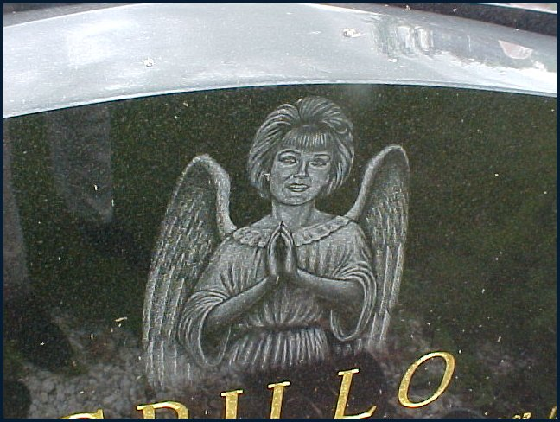
I am happy to report that soon after everyone forced the issue through design and complaint, this cemetery altered its rules and now permits not only personal images but also secular emblems, logos and designs as well.
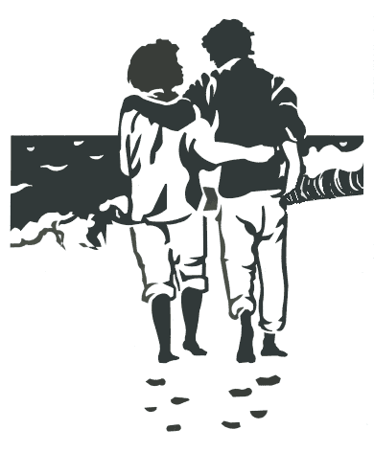
Cathy and I sat silently
upon a beach near Troy.
She alone with secret thoughts
and I alone with joy.
The wind blew soft, it swirled in moonlight
tossing the ocean toy.
While Cathy and I sat silently
upon a beach near Troy.
Within the twilight we did see
three ships go sailing by.
With huge white cannas slapping up
against a grayish sky.
And I turned to Cathy then
but battered not an eye.
For I knew what to answer her
as Cathy knows to I.
Days have numbered, nights were cast
since our lone meeting there.
But Cathy and I must go on,
our meetings are so rare.
But we will pocket that lone beach
and use it as a fare.
When Peter turns to Cathy
and I will not be there.

God Is:
The tapping of the waves.
The sunlight and rays.
The moments in your pocket.
The time, when you can't stop it.
The valley between the sand and our feet.
The land where you and your mind can meet.
The guider of rain to the earth below.
The earth, man, water and this whole entire show.

Ken to Me

Said Ken to me,
"I'd like to be, where younger waters flow."
Said I to he,
"We could never be, where younger seed is sown."
But could it be,
that I and he, could have aged thus as so?
When we did see
those still to be, our years and our know,
He turned to me
in order to see, that I was happy being old.

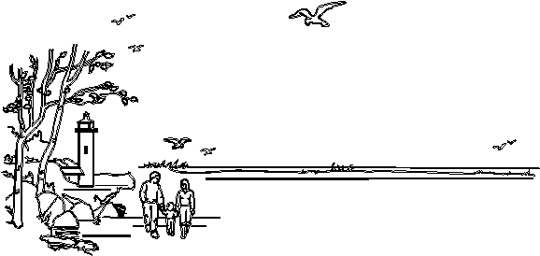
Drawing by permission of Bill Peisher, Woodburn Monuments

And He said, "Come in and go out.
Bring in a few stones and scatter them about.
Rise up to the highest point, then roll back out.
"Come forth to bathe my heated soil.
Spring up to the sky, then fall, then recoil.
Let all mankind see thy wonder and brief toil.
So they may know me.
"Giver of life you are called.
Spread yourself wide, tide out and fear not a fall.
Bring on the rains and devour all lands so tall."
So they may know me.
“For that is their way.
And as beautiful as it may be,
More so is the ocean, sea, river and bay.

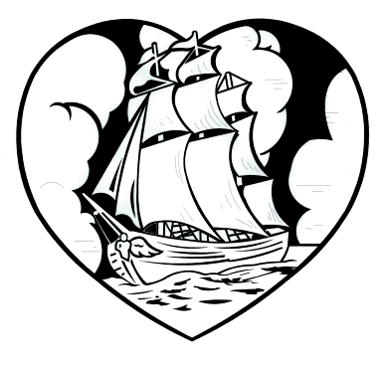

Blessed is the ship that takes me home.
May the wind fill her sail.
And the Bow and Stern, may they never moan.
May the waters form her tale.
Lovely is the clipper that sees me along.
May her captain see no storm.
And let the wind whisper like a siren’s song.
May her crew see each beautiful morn.
Let the ship which takes me home,
Be proud to sail the sea.
And Neptune below God's parting foam,
Allow her course be free.

APPENDIX A

Besides the select flowers purchased at a cemetery flower shop are these common flowers from residential shops and from your own garden. Here, according to Teleflora are the meanings to common flowers.

ACACIA - Concealed Love, Beauty in Retirement, Chaste Love
AMBROSIA - Your Love is Reciprocated
AMARYLLIS - Pride, Pastoral Poetry
ANEMONE - Forsaken
ARBUTUS - Thee Only Do I Love
ASTER - Symbol of Love, Daintiness
AZALEA - Take Care of Yourself for Me, Temperance, Fragile Passion, Chinese Symbol of Womanhood
BACHELOR BUTTON - Single Blessedness
BEGONIA - Beware
BELLS OF IRELAND - Good Luck
BITTERSWEET - Truth
BLUEBELL - Humility
CACTUS - Endurance
CAMELLIA (PINK) - Longing for you
CAMELLIA (RED) - You're a Flame in My Heart
CAMELLIA (WHITE) - You're Adorable
CARNATION (GENERAL) - Fascination, Woman Love
CARNATION (PINK) - I'll Never Forget You
CARNATION (RED) - My Heart Aches For You, Admiration
CARNATION (PURPLE) - Capriciousness
CARNATION (SOLID COLOR) - Yes
CARNATION (STRIPED) - No, Refusal, Sorry I Can't Be With You, Wish I Could Be With You
CARNATION (WHITE) - Sweet and Lovely, Innocence, Pure Love, Woman's Good Luck Gift
CARNATION (YELLOW) - You Have Disappointed Me, Rejection
CATTAIL - Peace, Prosperity
CHRYSANTHEMUM (GENERAL) - You're a Wonderful Friend, Cheerfulness and Rest.
CHRYSANTHEMUM (WHITE) - Truth
CHRYSANTHEMUM (YELLOW) - Slighted Love
CROCUS - Cheerfulness
CYCLAMEN - Resignation and Good-bye
DAFFODIL - Regard, Unrequited Love, You're the Only One, The Sun is Always Shining when I'm with You
DAISY - Innocence, Loyal Love, I'll Never Tell, Purity
DANDELION - Faithfulness, Happiness
FERN - Magic, Fascination, Confidence and Shelter
FIR - Time
FLAX - Domestic Symbol
FORGET-ME-NOT - True Love, Memories
FORSYTHIA - Anticipation
GARDENIA - You're Lovely, Secret Love
GERANIUM - Stupidity, Folly
GLADIOLI - Give Me a Break, I'm Really Sincere, Flower of the Gladiators
GLOXINIA - Love at First Sight
HEATHER (LAVENDER) - Admiration, Solitude
HEATHER (WHITE) - Protection, Wishes Will Come True
HOLLY - Defense, Domestic Happiness
HYACINTH (GENERAL) - Games and Sports, Rashness, Flower Dedicated to Apollo
HYACINTH (BLUE) - Constancy
HYACINTH (PURPLE) - I am Sorry, Please Forgive Me, Sorrow
HYACINTH (RED OR PINK) - Play
HYACINTH (WHITE) - Loveliness, I'll Pray for You
HYACINTH (YELLOW) - Jealousy
HYDRANGEA - Thank You for Understanding, Frigidity, Heartlessness
IRIS - Fleur-de-lis, Emblem of France, Your Friendship Means so Much to Me, Faith, Hope, Wisdom and Valor, My Compliments
IVY - Wedded Love, Fidelity, Friendship, Affection
JONQUIL - Love Me, Affection Returned, Desire, Sympathy, Desire for Affection Returned
LARKSPUR (PINK) - Fickleness
LILY (WHITE) - Virginity, Purity, Majesty, It's Heavenly to be with You
LILY (YELLOW) - I'm Walking on Air, False and Gay
LILY (CALLA) - Beauty
LILY (DAY) - Coquetry, Chinese Emblem for Mother
LILY (EUCHARIS) - Maiden Charms
LILY (TIGER) - Wealth, Pride
LILY OF THE VALLEY - Sweetness, Tears of the Virgin Mary, Return to Happiness, Humility, You've Made My Life Complete
MAGNOLIA - Nobility
MARIGOLD - Cruelty, Grief, Jealousy
MISTLETOE - Kiss me, Affection, To Surmount Difficulties, Sacred Plant of India
MONKSHOOD - Beware, A Deadly Foe is Near
MOSS - Maternal Love, Charity
MYRTLE - Love, Hebrew Emblem of Marriage
NARCISSUS - Egotism, Formality, Stay as Sweet as You Are
NASTURTIUM - Conquest, Victory in Battle
OLEANDER - Caution
ORANGE BLOSSOM - Innocence, Eternal Love, Marriage and Fruitfulness
ORANGE MOCK - Deceit
ORCHID - Love, Beauty, Refinement, Beautiful Lady, Chinese Symbol for Many Children
ORCHID (CATTLEYA) - Mature Charm
PALM LEAVES - Victory and Success
PEONY - Shame, Happy Life, Happy Marriage
PETUNIA - Resentment, Anger, Your Presence Sooths Me
PINE - Hope, Pity
POPPY (GENERAL) - Eternal Sleep, Oblivion, Imagination
POPPY (RED) - Pleasure
POPPY (WHITE) - Consolation
POPPY (YELLOW) - Wealth, Success
PRIMROSE - I Can't Live Without You
PRIMROSE (EVENING) - Inconstancy
ROSE (BRIDAL) - Happy Love
ROSE (DARK CRIMSON) - Mourning
ROSE (HIBISCUS) - Delicate Beauty
ROSE (LEAF) - You May Hope
ROSE (PINK) - Perfect Happiness, Please Believe Me
ROSE (RED) - Love, I Love You
ROSE (TEA) - I'll Remember Always
ROSE (THORNLESS) - Love at First Sight
ROSE (WHITE) - Innocence and Purity, I am Worthy of You, You're Heavenly, Secrecy and Silence
ROSE (WHITE AND RED MIXED) - Unity, Flower Emblem of England
ROSE (WHITE-DRIED) - Death is Preferable to Loss of Virtue
ROSE (YELLOW) - Decrease of Love, Jealousy, Try to Care
ROSEBUD - Beauty and Youth, A Heart Innocent of Love
ROSEBUD (RED) - Pure and Lovely
ROSEBUD (WHITE) - Girlhood
ROSEBUD (MOSS) - Confessions of Love
ROSES (Bouquet of Mature Blooms) - Gratitude
ROSES (Single Full Bloom) - I Love You, I Still Love You
SMILAX - Loveliness
SNAPDRAGON - Deception, Gracious Lady
SPIDER FLOWER - Elope with Me
STEPHANOTIS - Happiness in Marriage, Desire to Travel
STOCK - Bonds of Affection, Promptness, You'll Always Be Beautiful to Me
SWEETPEA - Good-bye, Departure, Blissful Pleasure, Thank You for a Lovely Time
TULIP (GENERAL) - Perfect Lover, Frame, Flower Emblem of Holland
TULIP (RED) - Believe Me, Declaration of Love
TULIP (VARIEGATED) - Beautiful Eyes
TULIP (YELLOW) - There's Sunshine in Your Smile
VIOLET - Modesty
VIOLET (BLUE) - Watchfulness, Faithfulness, I'll Always Be True
VIOLET (WHITE) - Let's Take a Chance
ZINNIA (MAGENTA) - Lasting Affection
ZINNIA (MIXED) - Thinking (or In Memory) of an Absent Friend
ZINNIA (SCARLET) - Constancy
ZINNIA (WHITE) - Goodness
ZINNIA (YELLOW) - Daily Remembrance

APPENDIX B

Concerning flower holders for mausoleums. By the time you read this, such mausoleum holders may be widely distributed. Check with your local flower shop. If they do no carry them, individual holders can be purchased directly from the author through his website: www.joepegasus.com Bulk orders can be purchased from the following wholesaler:
www.creativefloralsupply.com

Interesting Links
www.mydrawingboard.com All the art work you see in this book is from this online archive. The world's oldest and largest online archive of Commemorative CADD drawings. Although it is not for public consumption, it is interesting to browse. The author is the Drawing Board’s creator, founder and website developer.
www.nfda.org The National Funeral Directors Association (NFDA) is the largest funeral service organization in the world, dedicated to funeral service profession.
www.monumentbuilders.org Monument Builders of North America.
www.egaonline.com The Elberton Granite Association, Inc. represents more than 150 member firms. In addition to encouraging traditional memorialization and high standards of quality, the Elberton Granite Association, Inc. also maintains a voice in the national and international granite industry with regard to market development and technology.
www.nfda.org The National Funeral Directors Association (NFDA) is the largest funeral service
www.findagrave.com Find graves of rich and famous. Find the graves of ancestors, create virtual memorials, add 'virtual flowers' and a note to a loved one's grave, etc.
www.gravematter.com Historic cemetery site. Excellent source to New England burial grounds; including individual gravesites
www.hollyhockfarms.com/coweld/cemetery/cleaning_gravestones.htm Advice on cleaning grave markers. By Camille Bowman, Architectural Conservator.
www.rootsweb.com/%7Enhoga/misc_articles/cleaninggravestones.htm Advice on cleaning old grave stones by Trina Purcell with the help of the Association for Gravestone Studies, Rebecca Reynolds of the Museum of Fine Arts in Boston, and publications by conservators Lynette Strangstad and Tracy C. Walther.
www.fontfiles.com a massive selection of fonts and lettering styles.

APPENDIX C

Many bemoan the lost art of carving fanciful and endearing epitaphs as found on Victorian and older tomb stones from quaint cemeteries dotting our countryside. It appears that both monument builder and our family in mourning have lost touch with humanity and our down-home ways. When, in reality, the nature of memorialization had undergone a change due to several factors. These changes are cultural and occur all the time. Whereas many say the epitaphs of today pay no testament to the life or death of the buried, a peek at the epitaphs these folks point out for us are quaint and curious but not of our age. Especially the epitaphs from older American cemeteries which are froth with the struggles against nature, Indians, England and each other, is stuff best left to legal documents, books and movies. One does not need to visit the grave of a lost one and have to listen to a message of doom and disaster; or cowboys and Indians. The fact that changes happen is self evident proof that no one cared much for the old way of doing it. These artifacts are immensely important, yes; but the style was a short-lived expression and serves my generation not at all.
Then there are economic forces. What had occurred happened in New England during the late 19th century, and just where one would expect it to hatch – in Vermont, the granite capitol of the world. The new wave of Capitalism as technocracy, that still has this country in its grip, forced monument builders to create tomb stones of greater durability, size and finer design works. The early term of ‘tablature’ soon morphed into ‘monolith’ and ‘die’ reflecting the newer styles and purposes. Suddenly two attitudes sprang up, both caused by the lust for bucks: A Victorian notion that wealth expressed in stone reflected honest sorrow for the departed. And, the new style of memorialization sought money as its reward, thus prices have inflated ever since. Two fallacies reside here: the concept that we feel sorry for the departed and that memorialization requires financial investment. These concept live with us presently. They are slowly falling away to a return to traditional values. We do not feel sorrow for the departed, we mourn and hold vigil for them, then we remember their lives and times. How can anyone feel sorry for one who hopefully is with God in heaven? We may feel sorrow for our own loss, however, no one else will share your sorrow if you erect a 4 story monument in the honor of the departed. Because of such factors – economics and estranged views – cemetery property grew in value. The most expensive real estate in America today is cemetery property. Graves are stacked three high and any survey map will show there is no space at all between graves. With the 20th century introduction of public mausoleums, now we can stack 20 high above ground. Thus we loss space for the extended endearment, and epitaphs seem out of place. Out of place because of the 20th century notion of the bottom line. The cemetery is just an expensive dump, that’s the epitaph, the testament, the message. Over the last 150 years the monument builder had to incorporate into his carvings what would had otherwise been said in text. Successful to a point, the builder has been stymied by religious and secular cemeteries which openly defile human thoughts and feelings. What began as a movement toward big and beautiful ended as censored, sized and as sterilized as a crisp, new dollar bill.
As we adjust to this enormous change in the death care industry, things will get better and a more human face will reappear. Meaningful epitaphs and endearments are already making a come back. Expect valued, intelligent sayings to begin to appear – not the stuff better left to quaint books. Several of the following epitaphs would be prohibited in most modern cemeteries for two reasons: 1) Surface area on the marker limits the amount of expression, and 2) Due to legal ramifications, insurance companies who govern much of what happens around a cemetery will strike down any application that may cause a court battle. This last reason is slowly changing as cemeteries and insurance companies find ways to place all the blame on the deed holder. Sighting that the deed holder has the last say – except if the holder wants an out-right offensive text or design – drops all legal ramifications away from the cemetery and its agencies. It is then up to the deed holder to contend with angry relatives on his or her own.

Invest In Banks, And Your Life * The Lord Spoke, And She Was Gently Taken From Us * Here Lies No One * The Pot Was Full, And Still Is * Forever In Our Hearts * Finished Here * PEACE * Three People here, And Not There * Dream Often *
Step Lively As Wonderful * Not For Wrath * Returned – Unopened *
My loving friend as you pass by, On my cold grave pray cast an eye, Your sun like mine may set at noon, Your soul be called for very soon, In this dark place you'll quickly be, Prepare for death and follow me * William Shakespeare’s epitaph: "Good friend for Jesus' sake forbear,
To dig the dust enclosed heare! Blest be the man that spares thes stones, And cursed be he that moves my bones" * Here lies a miser who lived for himself, who cared for nothing but gathering wealth. Now where he is and how he fares; nobody knows and nobody cares * Wrestle Not With This * Blessed are the dead who die in the Lord. * Til Christ this body shall renew, Then both with joy shall meet again * Death is a debt to nature due, Which I've paid and so must you. * The die is cast, my hope, my fear. My pain, my joy lies buried here, And reader you before long must try, this dreaded change as well as I; Nor can a kinder ghost reveal what I have felt, and you must feel. * Among The Angels * Beloved until life could charm no more. And loved until God shall thee restore. * Little children come here and learn, that death may cut you down while young. * This Is All There Is & Kings May Have No More * Exchange A Life Of Great Distress For One Of Endless Happiness

Endearments are personal epitaphs. They seldom address the issue of mortality. Instead an endearment reminds the visitor about feelings and memories, once personally shared, concerning the departed. Here are a few actual endearments.
Those who cared for him while living will know who is buried here. To others it does not matter. From Hartford, Conn, 1882
In Death Valley, CA: Here lies the body of poor Aunt Charlotte Born a virgin, died a harlot. For sixteen years she kept her virginity A damn'd long time in this vicinity
From a cemetery in Winchendon, MA, on Stephen F. Fasset, who died in 1856: I began the preserving of cow's milk with white sugar for the use of steamers crossing the Atlantic Ocean.
Moultrie, GA,: Here lies the father of twenty-nine. He would have had more but he didn't have time
Burlington, Ma: Here lies the body of Susan Lowder, Who burst while drinking Deidlitz Powder | Called from the world to heavenly rest | She should have waited till it effervesced
Edinburgh, Scotland: Stranger, tread this ground with gravity | Dentist Brown is filling his last cavity
Saint James Cemetery, Toronto,Canada :When I am dead and in my grave, and all my bones are rotten. While reading this you'll think of me when I am long forgotten!

Old Stockbridge Cemetery, Stockbridge, Mass: Died while returning from the springs for his health, 1809

Frankfort, Kentucky: He heard her tale of matchless woe, And burning for revenge he rose, And laid her base seducer low, And struck dismay to virtue's foes.

Wilda Elsie Bell’s headstone
Wilda Elsie Bell’s headstone verse: Shaver's Creek Presbyterian Cemetery, McAlevy's Fort, PA: Wild's last look we shall never forget, Though hard to see her expire. She smiled as she bade us adieu And said she was going up higher.
Central Burying Ground Carlisle, MA: Behold a little prattling boy | His father's hope his mother's joy
Why should he make so short a stay | To steal our hearts & run away?
St. Charles Cemetery, Long Island, N.Y. but now common: The Wind Beneath My Wing.

Recommended Reading:
The Gospel According To St. Mark
Epitaphs To Remember by Janet Greene, Alan C. Hood & Company, Inc, 1962
The Elements of Christian Symbolism, John Baldcock, Element, 1955
Stories in Stone:-- by Douglas Keister, Gibbs Smith, 2004

Apologies and Acknowledgments
Mrs. Rivky Kaplan of AskMoses.com for her tips about Hebrew visiting rites.
All the monuments you see reproduced in renderings are actual monuments originally designed by myself or contributors to my online archive. However, names have been changed for the obvious reasons. Thus if you can read Hebrew, do not expect the Hebrew to match the English text.

